


Project ULAS EJ
ULAS Easy Justice

AY 2025 - 2026

AUTHORS:
Trisha Mae Sayson
INDIRECT LY AIDS:
CONT RIBUT ES TO:




CO-AUTHORS:
Roselle Wednesday Gardon
Manuel Sebastian Sanchez
Carl Dominique Bueno

Table of Contents
Project ULAS EJ 1
AY 2025 - 2026 1
Executive Summary iv
List of Figures v
List of Tables vi
Introduction 1
Project Context 1
Statement of the Problem 2
Objectives 3
Significance of the Project 3
Scope and Limitations 4
Review of Related Literature / Systems 5
Technical Background 12
Current System 12
Proposed System 13
Methodology 14
Requirements Analysis 14
Product Backlog / User Stories 14
Use Case Diagrams 19
Use Case Full Description 20
System Analysis and Design 28
Context Diagram 28
Data Flow Diagrams 28
Entity-Relationship Diagram 33
Activity Diagrams 34
Deployment Diagram 38
Results and Discussion 39
Prototype 40
User Classes and Characteristics 49
Recommendations 49
References 51
Appendices 55
Appendix A: Schedule 55
Appendix B: Users’ Manual 57
Appendix C: Team Meetings 58
Appendix D: Source Code 69
Appendix E: Curriculum Vitae 70
Appendix F: Links 72

Executive Summary
Access to justice remains a critical gap in the Philippines: despite constitutional guarantees, many indigent Filipinos cannot secure timely legal assistance due to structural barriers such as high legal costs, limited attorney availability, and geographic constraints. State legal aid mechanisms, while foundational, lack essential operational support for day‑to‑day pro bono service delivery, resulting in administrative inefficiencies, fragmented documentation practices, and limited transparency for clients. These challenges hinder effective case management, reduce compliance accuracy, and exacerbate burdens on both legal aid providers and beneficiaries.

To address these systemic deficiencies, this study proposes ULAS Easy Justice, a web‑based case management and collaboration platform designed to complement the official Unified Legal Aid Service (ULAS) Portal. Unlike ULAS Portal’s current focus on compliance reporting, ULAS Easy Justice provides an operational workspace tailored to the needs of Covered Lawyers and Qualified Beneficiaries. It integrates intuitive case dashboards, service entry logging, centralized document management, scheduling tools, and real‑time compliance visualization — all while maintaining secure role‑based access. The platform also enhances beneficiary transparency by giving clients access to case progress and activity timelines, thereby fostering trust and inclusion.

The platform’s implementation promises measurable improvements in legal aid delivery: operational efficiency for lawyers, reduced administrative burden and errors, enhanced documentation quality, and increased beneficiary engagement. By aligning daily workflows with compliance preparation and safeguarding the integrity of service hours even when cases are transferred or terminated, the proposed system strengthens both service quality and reporting accuracy. As such, ULAS Easy Justice advances the ULAS program’s mandate to ensure that access to legal services is not denied by reason of poverty, contributing to broader social justice and equity outcomes.

List of Figures
Figure 1: Use Case Diagram 19
Figure 2: Context Diagram 28
Figure 3: Data Flow Diagram Level 1 29
Figure 4: Data Flow Diagram Level 2 (Manage Case) 30
Figure 5: Data Flow Diagram Level 2 (Manage Account) 31
Figure 6: Data Flow Diagram Level 2 (Manage Lawyer-Qualified Beneficiary Collaboration) 32
Figure 7: Data Flow Diagram Level 2 (Manage Service Rendered) 33
Figure 8: Entity Relationship Diagram 34
Figure 9: Activity Diagram (Manage Case) 35
Figure 10: Activity Diagram (Manage Account) 36
Figure 11: Activity Diagram (Manage Lawyer-Qualified Beneficiary Collaboration) 37
Figure 12: Activity Diagram (Manage Service Rendered) 38
Figure 13: Deployment Diagram 39

List of Tables
Table 1: Product Backlog/ User Stories 14
Table 2: Use Case Full Description (Manage Case) 20
Table 3: Use Case Full Description (Manage Account) 22
Table 4: Use Case Full Description (Manage Lawyer-Qualified Beneficiary Collaboration) 24
Table 5: Use Case Full Description (Manage Service Rendered) 26
Table 6: User Classes and Characteristics 39

Introduction

Project Context

Access to justice is a fundamental human right guaranteed by Article III, Section 11 of the Philippine Constitution, which provides that free access to courts and adequate legal assistance shall not be denied by reason of poverty [1]​. Despite this constitutional mandate, the Philippines continues to face a significant justice gap. The World Justice Project reports that only 20% of Filipinos were able to access legal help, leaving the majority to navigate legal problems without professional support [2]​. The gap is made worse by structural obstacles, such as expensive legal fees, remote locations, a lack of lawyer interaction, and time limits. One attorney for every 2,200 Filipinos, well below the ideal ratio recommended by the Magee Rule Curve [2]​, contributes to these difficulties. Overwhelming caseloads put pressure on the quality of services provided by the Public Attorney's Office (PAO), the main state legal aid provider [3]​.

Recognizing this crisis, the Supreme Court of the Philippines established the Unified Legal Aid Service (ULAS) program to mobilize the entire Philippine Bar in providing pro bono legal services to qualified beneficiaries [4]​. Under this mandate, all covered lawyers are required to render 60 hours of free legal services within each three-year compliance period, with fulfilment reported through the official ULAS Portal administered by the Unified Legal Aid Service Office (ULASO) [5]​. With approximately 70,000 active members of the Integrated Bar of the Philippines (IBP), ULAS represents the most extensive nationwide legal aid mobilization effort in Philippine history [6]​.

The ULAS Portal serves as the government’s official compliance and reporting system, enabling lawyer registration, QB case number creation, service entry recording, financial contributions, reimbursement claims, and certification of compliance under oath. Its architecture prioritizes data collection, validation, and regulatory oversight allowing ULASO to assess compliance, issue Certificates of Compliance, and impose penalties for noncompliance [5]​. However, while effective as a compliance registry, the Portal wasn’t designed to support operational realities of day-to-day legal practice. It lacks essential workflow features such as centralized case dashboards, document management, scheduling tools, draft tracking, and real-time compliance visualization. Moreover, qualified beneficiaries have no access to the Portal, resulting in a lack of transparency regarding case progress.

As a result, covered lawyers are relying on multiple separate systems like spreadsheets for tracking hours, file folders for documents, calendars for scheduling, and phone calls for client communication, to manage pro bono cases. This increases administrative burden and increases errors and omissions when preparing compliance reports. For qualified beneficiaries, the complete absence of transparency contradicts client-centered legal service delivery.

To address this gap, this study proposes the development of ULAS Easy Justice, a web-based case management and collaboration platform that serves as the workspace for pro bono legal service delivery. Unlike the ULAS Portal, which remains the official system for compliance reporting, ULAS Easy Justice supports the operational workflow of covered lawyers and provides qualified beneficiaries with transparent access to case progress. The platform integrates case management tools, real-time service logging, document organization, compliance monitoring, and beneficiary-facing progress visibility, positioning itself as a complementary system within the ULAS ecosystem.

The primary stakeholders of this project are Covered Lawyers and Qualified Beneficiaries, with ULASO as an indirect institutional beneficiary. By improving operational efficiency, ULAS Easy Justice supports lawyers’ capacity to serve more clients, enhance documentation accuracy, and reduce compliance deficiencies. When applied across all ULAS-covered lawyers, even small reductions in administrative time can collectively free up thousands of hours each year that may be redirected to client representation. Transparent case visibility fosters agency, trust, and inclusion for beneficiaries, which is especially important for underrepresented groups who have historically been excluded from the judicial system [7]​. Improved compliance preparation decreases the assessment burden for ULASO while also strengthening program sustainability.

By enhancing the day-to-day delivery of pro bono services while preserving the ULAS Portal’s regulatory role, ULAS Easy Justice advances the ULAS program’s vision and strengthen the constitutional guarantee that access to justice shall not be denied by reason of poverty.

Statement of the Problem

Despite the establishment of the ULAS Portal as an official compliance reporting system, the ULAS program lacks an operational platform to support the day-to-day management and transparency of pro bono legal services. Covered lawyers rely on different tools to manage cases, while qualified beneficiaries have no visibility in case progress. This operational gap increases administrative burden, contributes to documentation errors, and undermines both service quality and compliance efficiency.

Based on the context described above, this study seeks to address the following problems:
- Lack of a dedicated case management workspace for organizing and managing pro bono legal services
- Lack of transparency in case information sharing between lawyers and beneficiaries
- Absence of real-time compliance visibility during compliance period, increasing the risk of deficiencies and penalties
- Lack of monitoring of legal documents submitted for case work and compliance documentation

Objectives

To develop a web-based case management and collaboration platform that provides covered lawyers with operational tools for organizing and documenting pro bono cases in real-time, while enabling qualified beneficiaries to transparently track case progress, thereby improving the efficiency and effectiveness of legal aid service delivery under the ULAS program.

1. To design workspace case management system that supports organization and management of pro bono cases
2. To create a collaboration workspace for both lawyers and qualified beneficiaries to monitor case progress.
3. To create real-time compliance tracking that reduces risks of deficiencies and penalties.
4. To be able to monitor all submissions of legal case documents requirements.

Significance of the Project

This study contributes to improving access to justice for indigent Filipinos by enhancing the operational efficiency and transparency of the ULAS program. Covered lawyers benefit from a centralized workspace that consolidates tracking systems, reducing administrative burden and saving time that can be redirected toward substantive legal work. Real-time compliance monitoring supports strategic planning throughout the three-year period, reducing deadline-related stress and minimizing documentation errors that trigger noncompliance penalties.

Qualified beneficiaries gain greater transparency in their legal representation, with access to information about their cases. Research shows that informed clients are more engaged, cooperate more fully with legal strategies, and provide timely information, all of which are associated with better case outcomes [7]​. ULASO also benefits from higher-quality compliance submissions, reducing assessment burden, enabling faster processing of Certificates of Compliance, and lowering the frequency of Notices to Comply.

ULAS Easy Justice aligns with global development priorities by advancing multiple Sustainable Development Goals. By improving pro bono service efficiency and transparency, it expands access to justice for marginalized populations, reduces inequalities based on economic status, protects indigent families from exploitation, supports women and vulnerable groups disproportionately affected by legal challenges, and upholds workers’ rights in labor-related cases. In this way, the study situates operational improvements in legal aid within a broader framework of social justice, equity, and sustainable development.

Scope and Limitations

This study covers the design and development of ULAS Easy Justice, a web-based platform aimed at supporting operational case management for covered lawyers and providing transparent case access for qualified beneficiaries. The system focuses on organizing, documenting, and tracking pro bono legal services within an academic, proof-of-concept environment. Its functionality is demonstrated using sample data to illustrate workflows, compliance monitoring, and information visibility.

The system does not connect to the official ULAS Portal, and any official compliance reporting would remain in manual. It is confined to the scope of individual lawyer and beneficiary interactions and does not cover broader organizational or administrative processes, financial transactions, or special legal procedures under the ULAS program. Security measures are basic, and the application is intended for demonstration purposes only. The platform relies on internet connectivity and does not provide offline functionality or native mobile applications. Development is constrained by time, resources, and the use of simulated data, focusing on proof-of-concept rather than production-ready deployment. No external system integrations with government databases or court systems are included.

Review of Related Literature / Systems
Introduction
This chapter reviews literature and systems relevant to developing ULAS Easy Justice. The review examines the access to justice gap, legal aid management systems, case management technology in legal practice, client-centered transparency, and compliance monitoring. By analyzing academic research, existing systems, and international practices, this chapter establishes the foundation for addressing the operational gaps identified in the ULAS program.
Access to Justice and the Legal Aid Gap
Access to justice remains a persistent challenge in many countries, where structural barriers prevent marginalized populations from exercising their legal rights. An estimated 5.1 billion people worldwide are affected, particularly women, children, the poor, persons with disabilities, and ethnic minorities, who experience extreme injustice, unresolved legal problems, and exclusion from the protections and opportunities provided by law [8]. In the Asia-Pacific region specifically, the UNDP's access to justice assessments indicates that persistent barriers stem from institutional capacity gaps and socio-economic and contextual obstacles, which reduce the responsiveness and accessibility of formal justice systems, particularly for disadvantaged and vulnerable groups [9].
Okoro [10] conducted a comprehensive qualitative study examining access to justice through 22 semi-structured interviews with legal aid providers, recipients, and stakeholders across various socioeconomic backgrounds. The research identified critical barriers organized into four categories: (1) awareness—many eligible individuals do not know legal aid services exist; (2) application processes—complex eligibility criteria and documentation requirements deter applicants; (3) service availability—geographic disparities leave remote populations underserved; and (4) demographic impacts—marginalized groups face compounded barriers due to language, education, and cultural factors. The study found that service quality depends significantly on lawyer expertise and client-lawyer relationships, while major systemic barriers include financial constraints, technological barriers, and cultural obstacles to seeking assistance.
The Philippine context reflects these global patterns. Research by Lopez [11] demonstrated that poor accused persons face “legal isolation” due to overworked public attorneys, lack of investigators, limited funds for bail or counsel, and low legal awareness, resulting in weaker defenses, constrained plea decisions, and higher conviction risk. This a situation further compounded in the Philippines by poverty-related factors such as weak legal aid access [12], class-biased policing [13], and low legal literacy [14, 15]. These systemic challenges illustrate why structural reforms and technological interventions are necessary to expand access beyond traditional service delivery models.

Case Management Systems in Legal Practice
Case management technology has evolved significantly over the past two decades, transforming from simple document repositories into comprehensive practice management tools. Commercial legal case management systems such as Clio [16], MyCase [17], and PracticePanther [18] offer integrated solutions that combine client relationship management, billing, document assembly, calendar management, and matter tracking. Research shows that well-designed legal case management systems can improve efficiency, reduce backlogs, and broaden access to justice when properly implemented in legal practice [19, 20, 21].
However, studies examining technology use in public interest law organizations reveal significant gaps between commercial tools and the specific needs of legal aid providers. Public interest organizations typically offer a range of services that extend beyond individual case representation, including legal education, social support, and community outreach. Most commercial legal software, designed primarily for private practice, focuses on billable client matters and lacks features to support these broader legal aid activities [22]. Furthermore, commercial systems are designed for profit-making law firms and prioritize revenue generation rather than the high-volume, resource-constrained operations typical of legal aid programs [23]. The mismatch between commercial system design and legal aid operational realities creates barriers to adoption and limits the effectiveness of technology in expanding access to justice.
Several specialized legal aid case management systems have emerged to address these gaps. LegalServer [24], widely adopted by civil legal aid providers in the United States, offers intake management, case tracking, and reporting tools tailored to legal services organizations. In Australia, the Community Legal Centres' Information Management System (CLCIMS) [25] provides similar functionality while incorporating funding accountability and outcome measurement features required by government legal aid grants. These systems show that purpose-built platforms can better support legal aid operations than adapted commercial tools.
The Philippine context presents unique considerations. Orbeta [26] evaluated the Philippine eCourt System across 305 courts in 13 judicial regions through quasi-experimental analysis, finding that while initial adoption required significant training and showed no impact during the first year, by the second year the system reduced case duration by 103 days and decreased pending caseloads significantly compared to non-digitized courts. However, the study also documented implementation challenges including the need for extensive technical training, dependency on stable internet connectivity, and a design oriented toward legal professionals rather than ordinary citizens. At the trial court level, manual docket books remain common, though a web-based Case Docket Information System piloted in a Regional Trial Court branch in Cagayan de Oro showed improvements in efficiency and data reliability while also highlighting early-stage adoption challenges and resource constraints typical of Philippine judicial technology initiatives [27]. The absence of unified case management platforms across legal aid and pro bono practice means that individual lawyers develop different tracking approaches, creating inconsistencies in documentation quality. International research suggests that standardized platforms with flexible workflows can maintain consistency while accommodating diverse practice contexts, particularly in coordinating services across independent practitioners with varying technological capabilities [28].
Client-Centered Technology and Transparency in Legal Services
The client-centered legal services movement emphasizes transparency, communication, and client agency as essential components of effective representation. Research shows that clients who receive regular case updates report higher satisfaction, better understanding of legal processes, and greater trust in their legal representatives [29]. Steinberg [30] argues that client autonomy in lawyer-client relationships requires information sharing that enables clients to make informed decisions about their own cases rather than passively receiving legal services. Empirical research on legal aid service delivery shows that better intake design, clear communication, and client engagement strategies contribute to more cooperative clients and improved legal outcomes, as clients who understand their case and process are more likely to participate meaningfully in their legal strategy and follow through with necessary steps. For example, studies reforming intake systems have found that empowering clients through better information flow enhances their engagement and legal case involvement [31, 32].
Client portals and collaborative platforms represent a technological response to these client-centered principles. Studies evaluating client portal implementations in both private firms and legal aid organizations show measurable benefits including reduced phone call volume, decreased client anxiety about case status, and improved client preparation for court proceedings [33]. Clio's 2023 Legal Trends Report [34] found that law firms offering client portals experienced significant reductions in routine status inquiry calls while reporting higher client satisfaction scores compared to firms relying solely on traditional communication methods. Furthermore, Steinberg [30] research indicates that transparency tools help address power imbalances inherent in lawyer-client relationships by providing clients with direct access to case information rather than requiring them to request updates, thereby fostering a more collaborative service model.
However, implementation research also identifies important challenges and design considerations for client-facing technology. Studies of legal technology for vulnerable populations emphasize the importance of simplified interfaces, mobile-responsive design, multilingual support, and progressive disclosure of information complexity [35, 28]. Hagan [35] emphasizes through human-centered design research that legal technology for vulnerable populations must intentionally prioritize plain language explanations and intuitive navigation over legal precision and comprehensive features. Cabral [28] found through usability testing of court technology that systems overwhelming users with legal terminology or requiring high digital literacy had significantly lower adoption rates among target populations, with confusion directly harming case outcomes when users could not navigate platforms effectively. These findings emphasize the importance of user-centered design that accounts for the technological capabilities and information needs of clients in legal aid contexts.
The concept of "legal empowerment" provides theoretical grounding for transparency-focused platforms. Sandefur [36] argues that access to justice should be reconceptualized as access to legal capability rather than merely access to lawyers, suggesting that empowering clients with information and tools to understand their own cases constitutes a form of access in itself. Golub [37] defines legal empowerment as giving people the knowledge, tools, and agency to use law to improve their lives, positioning information access as central to this approach. Evidence from legal empowerment programs demonstrates that when clients have access to structured case information and understand legal processes, they develop greater capacity to participate meaningfully in their own representation and navigate legal systems more independently in the future [37]. Technology platforms that provide transparent case information, explain legal processes, and enable client participation to contribute to this broader empowerment agenda while also improving immediate case outcomes through better-informed clients [36].
Compliance Monitoring and Reporting Systems
Compliance monitoring systems serve dual purposes in professional regulation: ensuring adherence to mandatory requirements and providing data for program evaluation and improvement. Rhode [38] documents that pro bono reporting systems must balance regulatory oversight with minimizing administrative burden on practitioners, as excessive reporting requirements can reduce actual service delivery by consuming time that could be spent on client representation. The American Bar Association's [39] voluntary pro bono reporting system demonstrates these challenges, achieving only partial participation despite decades of operation, with many lawyers citing reporting complexity as a barrier to participation. These findings suggest that effective compliance systems must prioritize usability alongside verification capability.
Real-time compliance tracking represents an evolution from periodic reporting models. Comparative analysis of professional development tracking systems shows that continuous monitoring approaches reduce year-end documentation crises and improve accuracy of service records compared to retrospective annual reporting [40]. The Law Society of Ontario [41, 42] exemplifies this integrated approach by incorporating pro bono reporting into annual practice declarations, embedding compliance tracking within existing regulatory processes rather than creating separate submission requirements. In the context of pro bono requirements specifically, research suggests that lawyers who track hours continuously throughout compliance periods distribute their service more evenly across the period and report lower stress levels compared to those who concentrate service delivery near reporting deadlines [43]. This pattern indicates that real-time tracking systems can improve not only compliance accuracy but also the temporal distribution and quality of service delivery.
The integration of compliance tracking with operational workflows addresses a key limitation of standalone reporting systems. A report on Thomson Reuters [44] legal tech adoption finds that many lawyers resist systems requiring separate administrative steps that do not directly support substantive legal work. Studies of regulatory compliance confirm that integrating reporting into regular workflows increases timely compliance, while separate submission requirements create higher rates of delayed or incomplete reporting [45]. Australia's National Pro Bono [46] Target system illustrates flexible integration, allowing lawyers to report through multiple pathways including law firm aggregation and direct submission, thereby accommodating diverse practice contexts while maintaining centralized tracking. These approaches show that compliance monitoring is most effective when embedded within systems lawyers already use for daily work rather than imposed as an additional administrative layer.
Related Systems and Platforms
Several existing systems provide relevant reference points for ULAS Easy Justice, though none directly addresses the specific operational needs of the Philippine ULAS program.
Several specialized legal aid case management systems have been developed between commercial tools and legal aid needs. LegalServer [24], widely adopted by civil legal aid providers in the United States, offers intake management, case tracking, and reporting tools specifically designed for legal services organizations, including features like eligibility screening, funding source tracking, and outcome measurement that commercial platforms lack. The Legal Services Corporation [47] reports that purpose-built systems like LegalServer are commonly adopted in the legal aid sector due to their design alignment with legal aid workflows and offer non-profit pricing. In Australia, the Community Legal Centres' Information Management System (CLCIMS) [25] provides similar functionality with added features for funding accountability and outcome measurement required by government grants. These examples show that platforms built specifically for legal aid work better than trying to adapt commercial tools.
In addition to case management, several platforms have pioneered client-facing transparency features. CaseStatus [48], a client communication platform, enables law firms provide secure case updates, document sharing, and messaging through a simple interface, with research showing improvements in client satisfaction and fewer phone calls. Commercial systems like Clio [16] and MyCase [17] now include client portals as standard features, allowing clients to access case information, communicate with attorneys, and upload documents securely. Legal Aid NSW's myLegalaid portal [49] shows how this works in a legal aid setting, providing case status tracking, appointment scheduling, and document submission through mobile-first design and simplified interfaces suitable for clients with varying digital literacy. These systems show that client-facing transparency tools can work across different practice contexts.
Various jurisdictions have also developed systems for tracking pro bono and professional compliance. New York State's pro bono reporting system [50] lets lawyers enter service hours through a web form and download compliance certificates after meeting the 50-hour requirement, showing a straightforward approach to mandatory hour tracking. The American Bar Association's voluntary pro bono reporting system [51] collects statistics for program evaluation, though voluntary participation limits how complete the data is. The Law Society of Ontario [41] integrates compliance reporting into annual practice declarations, embedding tracking within existing regulatory processes rather than creating separate submissions. These examples show different approaches to compliance tracking, each with trade-offs regarding administrative burden and user adoption.
Within the Philippine context, several digital justice initiatives provide relevant background. The eCourt System evaluation across 305 courts showed that digital case management reduced case duration by 103 days, though implementation required significant training and stable internet connectivity [26]. The ULAS Portal [5] serves as the official compliance and reporting system, handling registration and compliance certification, but it functions primarily as a reporting tool rather than a day-to-day case management system. The Public Attorney's Office [52] still relies on largely manual processes despite handling high caseloads. Some law school clinics have developed their own tracking systems using spreadsheets or simple databases. Overall, there is no unified case management platform across ULAS, resulting in inconsistent documentation practices and individualized tracking methods among covered lawyers.
Synthesis and Research Implications
This chapter reviewed literature on access to justice challenges, case management technology, client-centered design, and compliance monitoring systems. Several key findings emerged that inform the development of ULAS Easy Justice.
First, the access to justice gap in the Philippines reflects global patterns where structural barriers prevent marginalized populations from accessing legal help. The ULAS program represents a major policy response, mobilizing approximately 70,000 lawyers through a mandatory 60-hour pro bono requirement. However, as the literature shows, expanding service coverage requires not just more lawyers but also technological infrastructure to support actual service delivery.
Second, case management research shows that legal aid needs purpose-built platforms, not adapted commercial software. Commercial systems focus on billable hours and individual attorney productivity, while legal aid requires intake management, eligibility screening, funding tracking, and outcome measurement. International examples like LegalServer and CLCIMS show that purpose-built platforms work better because they match legal aid workflows rather than requiring workarounds.
Third, client-centered literature establishes that transparency and information access are essential for effective representation. Research shows that informed clients are more engaged, cooperate better with legal strategies, and have improved outcomes. Client portals address this need, though implementation research emphasizes designing for low-income populations through simplified interfaces, plain language, and progressive information disclosure.
Fourth, compliance monitoring research shows that effective systems integrate tracking with operational workflow rather than creating separate administrative burdens. Real-time monitoring improves accuracy, reduces stress, and enables even distribution of service across compliance periods.
However, there is a significant gap between what the research shows and what exists in the Philippine ULAS context. The ULAS Portal functions as a compliance registry for reporting hours, but it wasn't designed to support day-to-day workflow. Covered lawyers use different tools like spreadsheets for hours, file folders for documents, calendars for scheduling, phone calls for communication with no systematic way to monitor legal documents for case work or compliance. This creates administrative burden, increases documentation errors, and leaves beneficiaries with no visibility into their case progress. There's also no real-time compliance visibility throughout the three-year period, so lawyers can't plan strategically and may concentrate on service near deadlines. The eCourt System shows that digital case management can work in Philippine contexts, but court digitization is different from legal aid operational platforms, leaving ULAS-specific needs unaddressed.
ULAS Easy Justice addresses this gap by integrating proven approaches into a unified platform that supports both operational workflow and transparency while complementing the ULAS Portal's regulatory function. From case management research, it provides centralized workspace features like case dashboards, document management with tracking for both case work and compliance, task tracking, and deadline management. From client-centered principles, it lets beneficiaries transparently access case information through a simplified interface designed for varying digital literacy. From compliance monitoring research, it embeds real-time hour tracking within operational activities, letting lawyers visualize compliance status throughout the three-year period and plan strategically. The platform reflects international best practices while accounting for Philippine-specific considerations like training needs, connectivity constraints, and user-centered design for resource-constrained contexts.
The reviewed literature provides theoretical foundations and practical design principles that guide ULAS Easy Justice's architecture and features. The case management research informs the feature set and workflow design. Client-centered literature shapes the beneficiary-facing components. Compliance monitoring research guides how tracking integrates with workflows. The international and Philippine context reviews establish where ULAS Easy Justice fits which complements the official ULAS Portal while addressing operational gaps that neither the Portal nor commercial alternatives currently fill. This chapter establishes that while components of effective legal aid technology exist separately across various systems, ULAS Easy Justice's contribution is integrating them into one unified platform specifically designed for the Philippine ULAS program.

Technical Background
This section examines the technological infrastructure of both the current and proposed systems within the ULAS program. It first describes the planned ULAS Portal based on the ULAS Manual and Supreme Court announcements, identifying its intended functions for compliance reporting. It then outlines the technical specifications for ULAS Easy Justice, detailing the technologies used in the developing a complementary platform that addresses operational workflow needs. This overview established how the proposed system supports day-to-day legal practice management while working alongside the official compliance registry.

Current System
Based on the ULAS Manual and Supreme Court announcements, the ULAS Portal is planned as an online portal under the Judiciary’s website (https://portal.judiciary.gov.ph) that will serve as the official compliance and reporting system for the ULAS program, administered by the Unified Legal Aid Service Office (ULASO). As for this writing, ULAS Portal is still under development and not yet operational.
According to the ULAS Manual, the Portal will be a web-based system accessible through standard web browsers, designed to manage the full lifecycle of ULAS compliance reporting. The system will support registration and account management, allowing covered lawyers to create individual accounts containing personal information such as name, roll number, contact details, and employment information. Registered Organizations will similarly create accounts with organizational details and authorized representatives. Lawyers claiming exemption from the ULAS requirement will be able to submit applications for Certificates of Exclusion directly through the Portal.
For compliance recording, ULAS Portal will enable lawyers to generate QB (Qualified Beneficiary) case numbers by uploading scanned QB forms and certifications. Service Entry logging will require lawyers to input mandatory fields including service hours, category of service, nature of service, and case details. Lawyers participating in accredited outreach programs will be able to enter Certificate of Activity Accreditation (CAA) numbers when logging corresponding service entries. The system will also handle financial contribution submissions, allowing lawyers to upload proof of remittance for payment verification.
ULAS Portal's reporting and monitoring functions will generate Compliance Reports that automatically consolidate all service entries and financial contributions recorded during the compliance period. Lawyers will be able to attach supporting documents to their reports and submit sworn certifications attesting to the accuracy of their entries. For financial management, the system will process reimbursement claims linked to specific service entries, verify financial contributions, issue official receipts upon successful verification, and send notifications when payment discrepancies are detected.
Administrative functions handled by ULAS Portal include issuing Notices to Comply when covered lawyers have deficient hours, generating Certificates of Compliance upon successful report submission, tracking appeal filings and resolutions, and issuing Final Notices of Noncompliance for lawyers subject to penalties. ULAS Portal will serve as the central communication channel between ULASO and covered lawyers for all compliance-related matters throughout the three-year compliance period.

Proposed System
ULAS Easy Justice is a web-based case management and collaboration platform developed using OutSystems 11 to support the day-to-day operations of covered lawyers and qualified beneficiaries in the ULAS program. Designed to complement the official ULAS Portal, the system focuses on case management, client transparency, and real-time compliance tracking, while the Portal remains the official compliance reporting tool. Implemented as a reactive web application, the platform provides a responsive interface accessible through standard web browsers on both desktop and mobile devices, without requiring a native mobile app.
The system includes role-based access for lawyers and beneficiaries, a case management dashboard with search and filtering, service entry logging with automatic hour calculation, document upload with file type validation, real-time compliance visualization through dashboard widgets, and simplified case views for beneficiaries. Lawyers can track QB case numbers, log service entries, and reference CAA numbers for accredited programs. OutSystems’ built-in capabilities, including pre-built UI components, drag-and-drop interface design, REST API generation, security features, and Excel export functionality, support rapid development and future integration possibilities.
ULAS Easy Justice is implemented as proof-of-concept within the OutSystems Personal Environment, which provides cloud hosting, storage, backup, and redundancy without requiring separate server setup. This environment is limited to single-developer use, has storage quotas, and cannot be deployed on custom servers. Full deployment would require a licensed OutSystems environment to support multi-developer collaboration, enterprise-grade infrastructure, and higher storage capacity.
Currently, the platform operates independently of the ULAS Portal, and integration for real-world deployment would require coordination with ULASO and adherence to government IT, data security, and privacy policies. Potential integration methods include exporting service entries to the official Portal or maintaining parallel workflows with manual compliance submission. Despite these limitations, the system is designed to scale the entire ULAS population of 70,000 lawyers and their beneficiaries, while complying with accessibility, cloud hosting, and secure data handling requirements.

Methodology
The system followed a structured approach, including requirements analysis, product backlog with user stories, use case diagrams and full descriptions, and system analysis and design. This involved reviewing the ULAS Manual and attempting communication with the Supreme Court. Context, data flow, entity-relationship, activity and deployment diagrams were also developed, each discussed in detail in its own section.

Requirements Analysis
This section presents the system’s functional requirements derived from user needs and system objectives. It includes user stories to capture stakeholder expectations, a use case diagram to illustrate system interactions, and detailed use case descriptions to explain system behavior.

Product Backlog / User Stories
As shown in Table 1, these user stories capture the functional requirements of the ULAS Easy Justice system from the perspective of its primary users. These describes how Covered Lawyers and Qualified Beneficiaries interact with the system to accomplish specific goals, serving as the basis for use case modeling and detailed system design.
Table 1: Product Backlog/ User Stories
ID | Sprint | Epic | User Story
1 | 1 | Case | As a Covered Lawyer, I want to receive QB case details from the ULAS Portal (simulated) after case registration so that it is automatically reflected in ULAS Easy Justice
2 | 1 | Case | As a Covered Lawyer, I want to view, search, and filter my cases by status, client, and date in a centralized dashboard so that I can manage my caseload efficiently.
3 | 1 | Case | As a Covered Lawyer, I want to view detailed case information including all documents and service entries so that I have complete case overview
4 | 1 | Case | As a Covered Lawyer, I want to add case notes or updates so that I can document important developments privately
5 | 1 | Case | As a Covered Lawyer, I want to upload documents to active cases so that all materials are centrally organized
6 | 1 | Case | As a Covered Lawyer, I want to organize documents into categories so that files are easy to find
7 | 1 | Case | As a Covered Lawyer, I want to initiate a case transfer to another lawyer after I have logged all related service entries so that cases can be reassigned when I can no longer continue representation
8 | 1 | Case | As a Covered Lawyer, I want to view cases pending transfer that have been assigned to me so that I can review them before acceptance
9 | 1 | Case | As a Covered Lawyer, I want to accept a transferred case by uploading the required certificate so that I can take over representation
10 | 1 | Case | As a Covered Lawyer, I want to terminate a case when QB details are found to be falsified so that I can close fraudulent cases
11 | 1 | Case | As a Covered Lawyer, I want my service hours to still count toward compliance even if a case is terminated so that my work is properly credited
12 | 1 | Case | As a Covered Lawyer, I want to view terminated cases in read-only mode so that I can reference past cases without editing them
13 | 1 | Case | As a Covered Lawyer, I want to mark cases as completed when legal services are finished so that my dashboard reflects current work
14 | 1 | Case | As a Covered Lawyer, I want to export case information including my service entries, notes, and uploaded documents so that I have offline documentation of the fully managed case.
15 | 1 | Account | As a Covered Lawyer, I want to access ULAS Easy Justice using my portal credentials so that I can manage cases assigned to me.
16 | 1 | Account | As a Covered Lawyer, I want my account details to be retrieved from the ULAS Portal so that my information remains consistent across systems.
17 | 1 | Account | As a Covered Lawyer, I want my access to be limited to cases assigned to me so that I cannot view or modify unrelated cases.
18 | 1 | Account | As a Qualified Beneficiary, I want to receive temporary login credentials after a lawyer creates a case so that I can access my case information.
19 | 1 | Account | As a Qualified Beneficiary, I want to update my temporary credentials to permanent ones so that I can securely access the system.
20 | 1 | Account | As a Qualified Beneficiary, I want my account to remain inactive until I set my permanent credentials so that my account is secure.
21 | 1 | Account | As a Qualified Beneficiary, I want to use the same account for multiple cases so that I do not need to create a new account each time.
22 | 1 | Account | As a Qualified Beneficiary with an activated account, I want to recover my password so that I can regain access if I forget my credentials.
23 | 1 | Account | As a Qualified Beneficiary, I want to view my profile information so that I can confirm my details without modifying authoritative records.
24 | 1 | Account | As a Qualified Beneficiary, I want to update login credentials or information so that my account remains secure and contactable.
25 | 2 | Covered Lawyer-Qualified Beneficiary Collaboration | As a Covered Lawyer, I want to control document sharing with my QB by granting, viewing, and revoking access so that I manage information visibility appropriately.
26 | 2 | Covered Lawyer-Qualified Beneficiary Collaboration | As a Covered Lawyer, I want to request information from my QB and track the status of those requests so that I know when required materials have been provided.
27 | 2 | Covered Lawyer-Qualified Beneficiary Collaboration | As a Covered Lawyer, I want to add reminders for hearings and consultations and notify my QB so that we stay aware of important dates.
28 | 2 | Covered Lawyer-Qualified Beneficiary Collaboration | As a Covered Lawyer, I want to see when my QB has viewed case updates so that I know they're staying informed
29 | 2 | Covered Lawyer-Qualified Beneficiary Collaboration | As a Covered Lawyer, I want to view my QB's uploaded documents so that I can access materials they've provided
30 | 2 | Covered Lawyer-Qualified Beneficiary Collaboration | As a Qualified Beneficiary, I want to view my profile showing basic information pulled from my case so that I can see my case details
31 | 2 | Covered Lawyer-Qualified Beneficiary Collaboration | As a Qualified Beneficiary, I want to view my case details, current status, updates, and activity timeline so that I understand the progress of my legal representation.
32 | 2 | Covered Lawyer-Qualified Beneficiary Collaboration | As a Qualified Beneficiary, I want to see lawyer-added reminders for hearings and consultations so that I do not miss important dates.
33 | 2 | Covered Lawyer-Qualified Beneficiary Collaboration | As a Qualified Beneficiary, I want to view documents that my lawyer has shared so that I can access relevant case materials.
34 | 2 | Covered Lawyer-Qualified Beneficiary Collaboration | As a Qualified Beneficiary, I want to see pending requests from my lawyer so that I know what actions I need to take
35 | 2 | Covered Lawyer-Qualified Beneficiary Collaboration | As a Qualified Beneficiary, I want to upload documents requested by my lawyer so that I can provide needed information
36 | 2 | Covered Lawyer-Qualified Beneficiary Collaboration | As a Qualified Beneficiary, I want to mark requests as completed when I fulfill them so that my lawyer knows I've responded
37 | 2 | Covered Lawyer-Qualified Beneficiary Collaboration | As a Qualified Beneficiary, I want to view work logged by my lawyer for my case so that I can see what services have been performed on my behalf.
38 | 2 | Covered Lawyer-Qualified Beneficiary Collaboration | As a Qualified Beneficiary, I want to see the timeline of services rendered so that I can track progress of my case.
39 | 2 | Covered Lawyer-Qualified Beneficiary Collaboration | As a Qualified Beneficiary, I want to receive notifications about important case events such as status changes, shared documents, requests, and service updates so that I stay informed.
40 | 2 | Covered Lawyer-Qualified Beneficiary Collaboration | As a Qualified Beneficiary, I want to view my terminated cases in read-only mode so that I can still reference past case information even though the case was closed due to falsified details
41 | 2 | Covered Lawyer-Qualified Beneficiary Collaboration | As a Qualified Beneficiary, I want to access my active cases with a different lawyer using my existing account so that all my cases are in one place
42 | 2 | Service Rendered | As a Covered Lawyer, I want to create a service entry linked to a case by recording required details such as category, nature of service, hours, description, and proof so that my work is properly documented.
43 | 2 | Service Rendered | As a Covered Lawyer, I want to manage service entry drafting, editing, finalizing, and deleting so that my records remain accurate and complete.
44 | 2 | Service Rendered | As a Covered Lawyer, I want to view all service entries for a specific case so that I can see the complete service history
45 | 2 | Service Rendered | As a Covered Lawyer, I want to view my total service hours, detailed breakdowns, and visual compliance progress indicators so that I can monitor my progress toward the 60-hour requirement.
46 | 2 | Service Rendered | As a Covered Lawyer, I want to filter service entries by date, case, status, category, and nature of service so that I can review specific subsets of my work.
47 | 2 | Service Rendered | As a Covered Lawyer, I want to export my service entries for Portal manual entry so that I can transfer data efficiently
48 | 2 | Service Rendered | As a Covered Lawyer, I want to mark a service entry as complete so that it is marked as ready for inclusion in compliance reporting and submission to the ULAS Portal.
49 | 2 | Service Rendered | As a Covered Lawyer, I want to add private notes to service entries for my own reference so that I can document additional context
50 | 2 | Service Rendered | As a Covered Lawyer, I want to understand that when I transfer a case, my accumulated service hours for that case remain with me so that my compliance tracking is accurate
51 | 2 | Service Rendered | As a Covered Lawyer, I want service entries to have a status (draft, submitted) so that I can manage compliance preparation.
52 | 2 | Service Rendered | As a Covered Lawyer, I want to generate a consolidated compliance summary for the current compliance period showing total hours rendered, case breakdown, and supporting service entries so that I can prepare accurate submission to the ULAS Portal.
53 | 2 | Service Rendered | As a Covered Lawyer, I want to see the remaining number of required hours for the current compliance period so that I can plan my pro bono commitments accordingly.
54 | 2 | Service Rendered | As a Covered Lawyer, I want to view my compliance period start date, end date, and progress status so that I understand my reporting timeline.
55 | 2 | Service Rendered | As a Covered Lawyer, I want to export a structured compliance report including all finalized service entries and supporting documentation so that I can submit complete records to the ULAS Portal.

Use Case Diagrams
The ULAS Easy Justice system diagram in Figure 1 serves as a microsite that supports account management, case handling, collaboration, and service logging. Covered Lawyers interact with all major use cases, including managing cases, accounts, lawyer–beneficiary collaboration, and services rendered. Qualified Beneficiaries interact with the system to manage their accounts and participate in case-related collaboration. ULAS Portal acts as an external system that provides lawyer and case information and supports account provisioning.
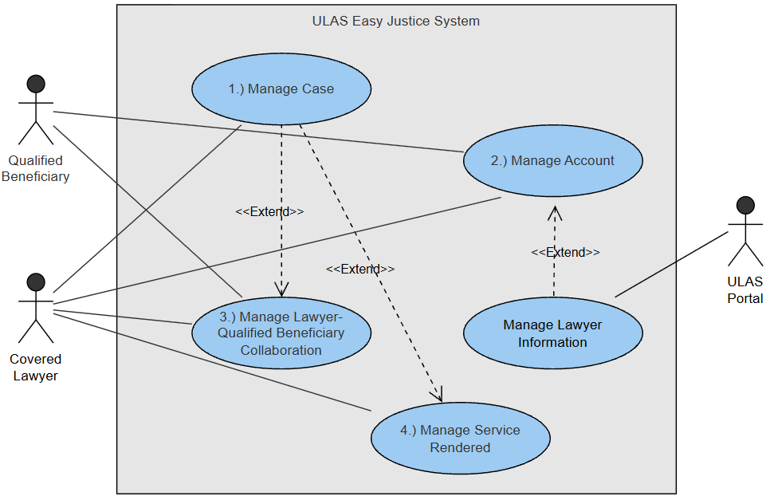
Figure 1: Use Case Diagram

Use Case Full Description
The following tables provide detailed descriptions of each use case, outlining the interactions between users and the system to fulfill requirements.
Table 2: Use Case Full Description (Manage Case)
Use Case Name: | Manage Case
Scenario: | This use case enables Covered Lawyers to manage their pro bono cases within ULAS Easy Justice. Case information is imported from the simulated ULAS Portal (for integration demonstration) after a QB Case Number is created. Lawyers can view case details, add private notes, upload and categorize documents, and manage case status (complete, terminate, or transfer). The system provides a centralized dashboard with search and filtering capabilities for efficient caseload management and preserves recorded service hours associated with cases.
Triggering Event: | - Covered Lawyer creates a Qualified Beneficiary Case in the ULAS Portal, and case information is transferred to ULAS Easy Justice.  - Covered Lawyer navigates the dashboard, views details, updates notes/documents, manages status, or accepts/reviews pending transfers.
Brief Description: | Covered Lawyer manages all aspects of their assigned cases within ULAS Easy Justice, including viewing, searching, updating, documenting, uploading files, transferring, terminating, and archiving cases.
Actors: | Covered Lawyer
Related Use Cases: | Manage Lawyer-Qualified Beneficiary Collaboration, Manage Service Rendered
Stakeholders: | Covered Lawyer
Preconditions: | - Covered Lawyer is authenticated in ULAS Easy Justice  - Relevant case(s) exist in the ULAS Portal or have been imported.  - System access to previously logged service entries and documents is available
Postconditions: | - Case information is updated, accurate, and reflected in the lawyer’s dashboard.  - Service entries linked to terminated or transferred cases remain credited to the lawyer’s compliance hours.  - Completed cases are automatically archived and removed from the active dashboard but remain accessible in read-only mode.  - Cases in Pending Transfer or Active status are accessible only to the assigned lawyer; sending lawyer can view in read-only mode during transfer  - Transferred cases retain service entry credit for the sending lawyer and are visible to the receiving lawyer only after certificate validation.
Flow of Activities: | Actor | System
Flow of Activities: | [1.1] Retrieve, view and filter case information  [1.2] Covered Lawyer updates case details, adds notes, uploads or organizes documents  [1.3] Covered Lawyer manages case status (complete, terminate, or transfer)  [1.4] Covered Lawyer(new) uploads required transfer certificate  [1.5] Covered Lawyer (new) rejects case transfer | [1.1.1] System displays a centralized list of active and past cases  [1.2.1] System validates inputs and saves updates to the case  [1.3.1] System updates case status to Completed and archives case from active dashboard  [1.3.2] System updates case status to Terminated and preserves service hour records  [1.3.3] System updates case status to Pending Transfer, restricts editing access for the sending lawyer (read-only mode), and creates transfer record.  [1.4.1] System validates certificate, updates case ownership, and changes status to Active  [1.5.1] System cancel transfer, restore ownership to sending lawyer, change status back to Active
Exception Conditions: | [1.1.1.a] Case retrieval failure: If case records cannot provide case details, the system displays an error message.  [1.2.1.a] File upload failure: If document upload is unsuccessful, notify the lawyer and allow retry.  [1.3.2.a] Invalid termination: If termination conditions are not met, system prevents termination.  [1.4.1.a] Certificate missing for transfer: If required certificate is not uploaded, prevent case transfer.
Table 3: Use Case Full Description (Manage Account)
Use Case Name: | Manage Account
Scenario: | This use case enables Covered Lawyers and Qualified Beneficiaries to access ULAS Easy Justice through secure authentication mechanisms. Covered Lawyers access the system using their ULAS Portal credentials; account information retrieved from the Portal is displayed in read-only mode. Qualified Beneficiaries receive temporary credentials after case creation, activate their accounts by setting permanent credentials, and reuse the same account across multiple cases. The system ensures secure access while preventing duplicate account creation.
Triggering Event: | - Covered Lawyer accesses ULAS Easy Justice via the ULAS Portal  - Qualified Beneficiary receives temporary credentials after case creation and attempts to log in  - Qualified Beneficiary accesses account-related functions after activation
Brief Description: | Covered Lawyer and Qualified Beneficiary access and manage user accounts in ULAS Easy Justice, including authentication, account activation, credential management (QB only), and account reuse.
Actors: | Qualified Beneficiary and Covered Lawyer
Related Use Cases: | Manage Case, Manage Lawyer-Qualified Beneficiary Collaboration, Manage Service Rendered
Stakeholders: | Qualified Beneficiary and Covered Lawyer
Preconditions: | - System is accessible via internet connection  - Covered Lawyer has active account in ULAS Portal with valid credentials  - Qualified Beneficiary case exists in ULAS Portal  - Qualified Beneficiary has received the secure access link via email
Postconditions: | - Covered Lawyer/ Qualified Beneficiary successfully accesses ULAS Easy Justice  - Covered Lawyer profile information from portal are displayed  - Qualified Beneficiary account is activated with permanent credentials  - Existing Qualified Beneficiary accounts are reused when linked to new cases.  - Any changes to login credentials or contact details are saved
Flow of Activities: | Actor | System
Flow of Activities: | [2.1] Covered Lawyer accesses ULAS Easy Justice via the ULAS Portal; Qualified Beneficiary logs in using temporary credentials  [2.2] Qualified Beneficiary sets permanent credentials  [2.3] Qualified Beneficiary views account information  [2.4] Qualified Beneficiary updates account information | [2.1.1] System authenticates the lawyer through the ULAS Portal and retrieves read-only account information; validates temporary credentials for Qualified Beneficiary  [2.2.1] System activates the account  [2.3.1] System displays profile details and account details  [2.4.1] System validates and saves the updated information
Exception Conditions: | [2.1.1.a] Invalid Portal Authentication: If the Covered Lawyer authentication with the ULAS Portal fails, the system denies access and displays an authentication error.  [2.1.1.b] Account information retrieval failure: If account details cannot be retrieved from the ULAS Portal or ULAS Easy Justice records, the system displays an error message and limits access to unavailable data.  [2.1.1.c] Invalid or expired temporary credentials: If the temporary credentials provided to the Qualified Beneficiary are invalid or expired, the system displays an error message and prevents account activation.  [2.2.1.a] Existing Account Detected: If the Qualified Beneficiary already has an activated account, the system links the new case to the existing account instead of creating a new one.  [2.2.1.b] Account activation failure: If the Qualified Beneficiary submits invalid permanent credentials, the system rejects the input and prompts the user to correct the information.  [2.4.1.a] Session Timeout: If the session expires during account update, the system requires re-authentication before saving changes.  [2.4.1.b] Invalid credential update: If updated login credentials do not meet validation rules, the system rejects the update and prompts the user to retry.

Table 4: Use Case Full Description (Manage Lawyer-Qualified Beneficiary Collaboration)
Use Case Name: | Manage Lawyer-Qualified Beneficiary Collaboration
Scenario: | This use case enables case-based collaboration between Covered Lawyers and Qualified Beneficiaries within ULAS Easy Justice. Lawyers can control document visibility, create and monitor information requests, review uploaded materials, and schedule case-related events. Qualified Beneficiaries can view authorized case information, respond to requests, upload documents, and receive notifications. All activities are restricted to assigned cases and governed by role-based access control.
Triggering Event: | - Covered Lawyer accesses a case collaboration page  - Covered Lawyer requests information or shares documents  - Qualified Beneficiary logs in and accesses case collaboration features  - Qualified Beneficiary uploads requested documents or views updates
Brief Description: | Facilitates secure, case-based collaboration between Covered Lawyers and Qualified Beneficiaries.
Actors: | Qualified Beneficiary and Covered Lawyer
Related Use Cases: | Manage Case, Manage Service Rendered
Stakeholders: | Qualified Beneficiary and Covered Lawyer
Preconditions: | - Covered Lawyer or Qualified Beneficiary is authenticated in ULAS Easy Justice  - The case exists and is assigned to Covered lawyer or Qualified Beneficiary  - Case access permissions are properly established  - Covered Lawyer or Qualified Beneficiary has accessed an assigned case and is currently inside the Case Collaboration section.
Postconditions: | - Document visibility settings are updated  - Requests are stored with current status (Pending / Completed)  - Uploaded documents are linked to the case  - Case events and reminders are stored in the system  - Collaboration history is reflected in the case timeline  - Notifications are triggered for Covered Lawyer or Qualified Beneficiary
Flow of Activities: | Actor | System
Flow of Activities: | [3.1] Covered Lawyer uploads a document and sets visibility for the Qualified Beneficiary  [3.2] Covered Lawyer creates an information or document request  [3.3] Qualified Beneficiary uploads a requested document  [3.4] Covered Lawyer reviews the uploaded document either approves or request for revision/ new document  [3.5] Covered Lawyer creates a case event (hearing, consultation, reminder) | [3.1.1] System saves the document, updates visibility, and logs the action  [3.1.2] System notifies the Qualified Beneficiary of the shared document  [3.2.1] System records the request as Pending, logs it, and notifies the Qualified Beneficiary  [3.3.1] System stores the document, links it to the case, updates request status to Completed, and notifies the lawyer  [3.4.1] System logs the review action  [3.5.1] System stores the event and notifies the Qualified Beneficiary
Exception Conditions: | [3.1.1.a] Document Sharing Failure: If document visibility cannot be updated or saved, the system displays an error and prevents sharing.  [3.1.1.b] Document Upload Failure: If the document upload fails due to invalid format, file size limit, or system error, the system displays an error message and allows retry.  [3.2.1.a] Request Recording Failure: If the request cannot be saved due to system error, the system displays an error and prevents submission.  [3.3.1.a] Document Upload Failure: If the document upload fails due to invalid format, file size limit, or system error, the system displays an error message and allows retry.  [3.3.1.b] Invalid Completion: If no document is attached, the system prevents marking the request as completed.  [3.5.1.a] Scheduling Conflict: If event date overlaps with an existing event for the same case, the system notifies the lawyer before saving.

Table 5: Use Case Full Description (Manage Service Rendered)
Use Case Name: | Manage Service Rendered
Scenario: | This use case allows Covered Lawyers to record, manage, and track legal services rendered for assigned cases in ULAS Easy Justice. Lawyers can create service entries by recording required details such as category, nature of service, hours rendered, description, and supporting proof. Service entries can be saved as drafts, finalized, submitted for portal reporting, and linked to compliance tracking. All service hours remain credited to the lawyer even when cases are transferred or terminated, and finalized entries are prepared for export to the ULAS Portal for compliance reporting.
Triggering Event: | - Covered Lawyer opens a case and selects service entry management  - Covered Lawyer creates, edits, or finalizes a service entry  - Covered Lawyer reviews compliance progress or service history
Brief Description: | Allows Covered Lawyers to document and monitor service hours for compliance purposes.
Actors: | Covered Lawyer
Related Use Cases: | Manage Lawyer-Qualified Beneficiary Collaboration
Stakeholders: | Covered Lawyer
Preconditions: | - Covered Lawyer is authenticated in ULAS Easy Justice  - At least one case is assigned to the lawyer  - Case status allows service entry recording
Postconditions: | - Service entries are saved with appropriate status  - Total service hours and compliance progress are updated  - Service entries marked as finalized are automatically included in the compliance report  - Service records remain accessible for reference and auditing  - Generated compliance report is securely stored and ready for submission to the ULAS Portal.
Flow of Activities: | Actor | System
Flow of Activities: | [4.1] Covered Lawyer creates or edits a service entry  [4.2] Covered Lawyer view service entry/ compliance progress  [4.3] Covered Lawyer drafts service entry and marks it as "Finalized and included in compliance report" once validated  [4.4] Covered Lawyer request compliance report for export / generation of compliance report. | [4.1.1] System validates required fields and saves the entry  [4.2.1] System displays existing service entries and total hours  [4.3.1] System updates entry status to ‘finalized and included in compliance report’ and locks editing  [4.4.1] System generates offline report for submission to ULAS Portal.
Exception Conditions: | [4.1.1.a] Invalid Hour Value: If rendered hours exceed logical limits (e.g., negative or unrealistic), system rejects input.  [4.1.1.b] Incomplete service entry: If required details are missing, the system prevents saving and prompts correction.  [4.1.1.c] Case Not Eligible: If case is closed/terminated/transferred, system prevents entry creation.  [4.3.1.a] Already Finalized: If entry is already finalized, system prevents further editing.  [4.3.1.b] Cannot Delete Finalized Entry: If a service entry has been finalized or included in a compliance report, the system prevents deletion and informs the lawyer.  [4.4.1.a] No Finalized Entries  If no finalized entries exist in current compliance period, system prevents report generation.  [4.4.1.b] Report Generation Failure: If report generation fails, system displays error and logs attempt.

System Analysis and Design
This section presents the system analysis and design of the ULAS Easy Justice system, highlighting its structure, behavior, and data interactions. It includes the Context Diagram, Data Flow Diagrams, Entity-Relationship Diagram, Activity Diagrams, and Deployment Diagram to illustrate the system actors, processes, workflows, data relationships, and technical architecture.

Context Diagram
The diagram in Figure 2 provides a high-level view of ULAS Easy Justice which shows how the system interacts with external actors, including Covered Lawyers, Qualified Beneficiaries, and the ULAS Portal. It illustrates the major inputs and outputs exchanged between these actors and the system, highlighting the boundaries of the system without detailing the internal processes.

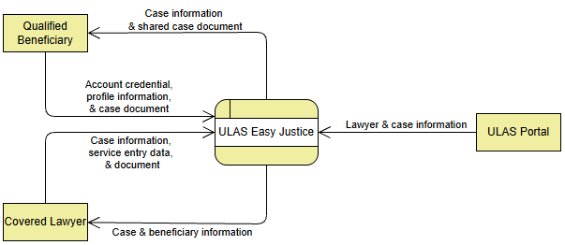
Figure 2: Context Diagram

Data Flow Diagrams
The following Data Flow Diagrams illustrate how data moves within the ULAS Easy Justice system, showing its major processes, data stores, and internal data interactions. These diagrams begin with Level 1 and are further decomposed into Level 2 for selected core processes.

Data Flow Diagram Level 1
Figure 3 shows the Level 1 Data Flow Diagram, which decomposes the system into four major processes: Manage Case, Manage Account, Manage CL–QB Collaboration, and Manage Service Rendered.
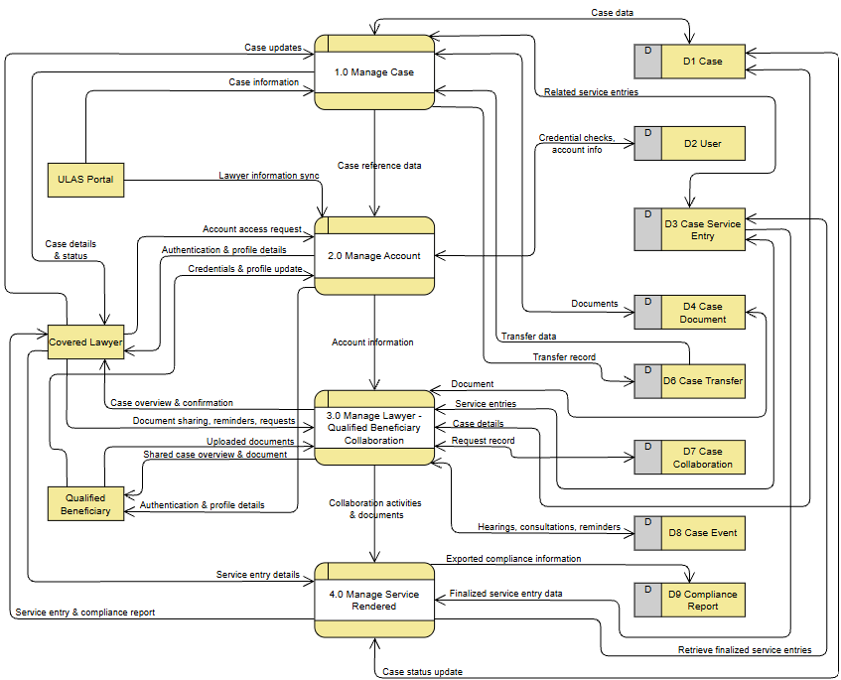
Figure 3: Data Flow Diagram Level 1

Manage Case
Figure 4 shows the Level 2 Data Flow Diagram for the Manage Case process, detailing case creation, updates, and retrieval, including interactions with related data stores.
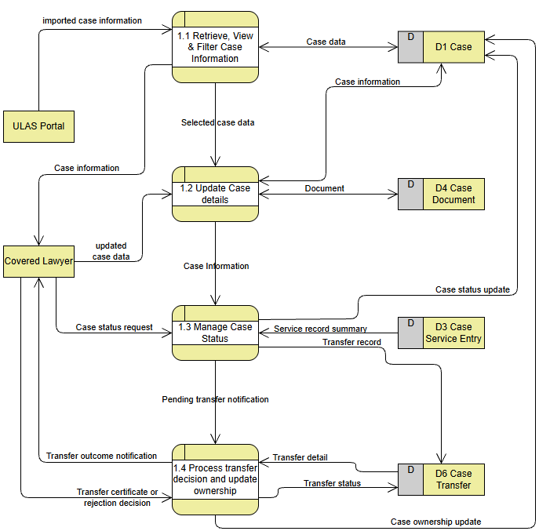
Figure 4: Data Flow Diagram Level 2 (Manage Case)

Manage Account
Figure 5 shows the Level 2 Data Flow Diagram for the Manage Account process, illustrating authentication, profile management, and account data handling.
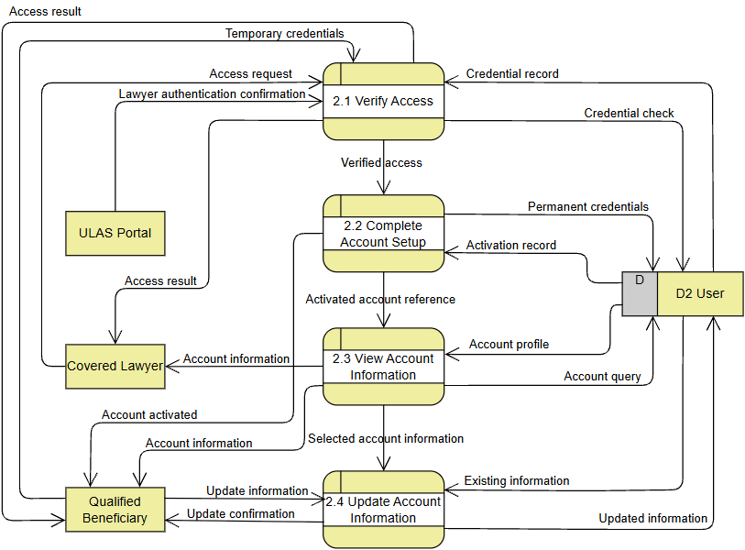
Figure 5: Data Flow Diagram Level 2 (Manage Account)

Manage Lawyer- Qualified Beneficiary Collaboration
Figure 6 shows the Level 2 Data Flow Diagram for the Manage CL–QB Collaboration process, illustrating document sharing, collaboration tracking, and case-related interactions between users.
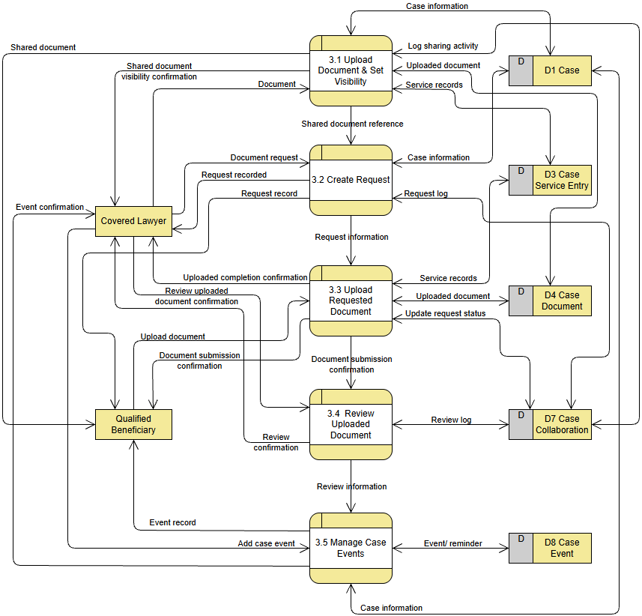
Figure 6: Data Flow Diagram Level 2 (Manage Lawyer-Qualified Beneficiary Collaboration)

Manage Service Rendered
Figure 7 shows the Level 2 Data Flow Diagram for the Manage Service Rendered process, detailing service entry recording, validation, and compliance report generation.
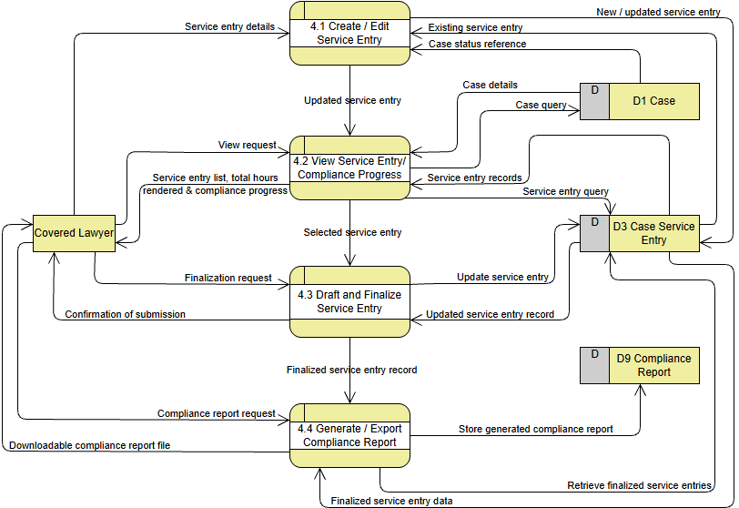
Figure 7: Data Flow Diagram Level 2 (Manage Service Rendered)

Entity-Relationship Diagram
Upon defining the system processes and business process, the developer created the Entity-Relationship Diagram for ULAS Easy Justice. Figure 8 illustrates the complete ERD used to organize and manage data such as users, cases, service entries, and documents.
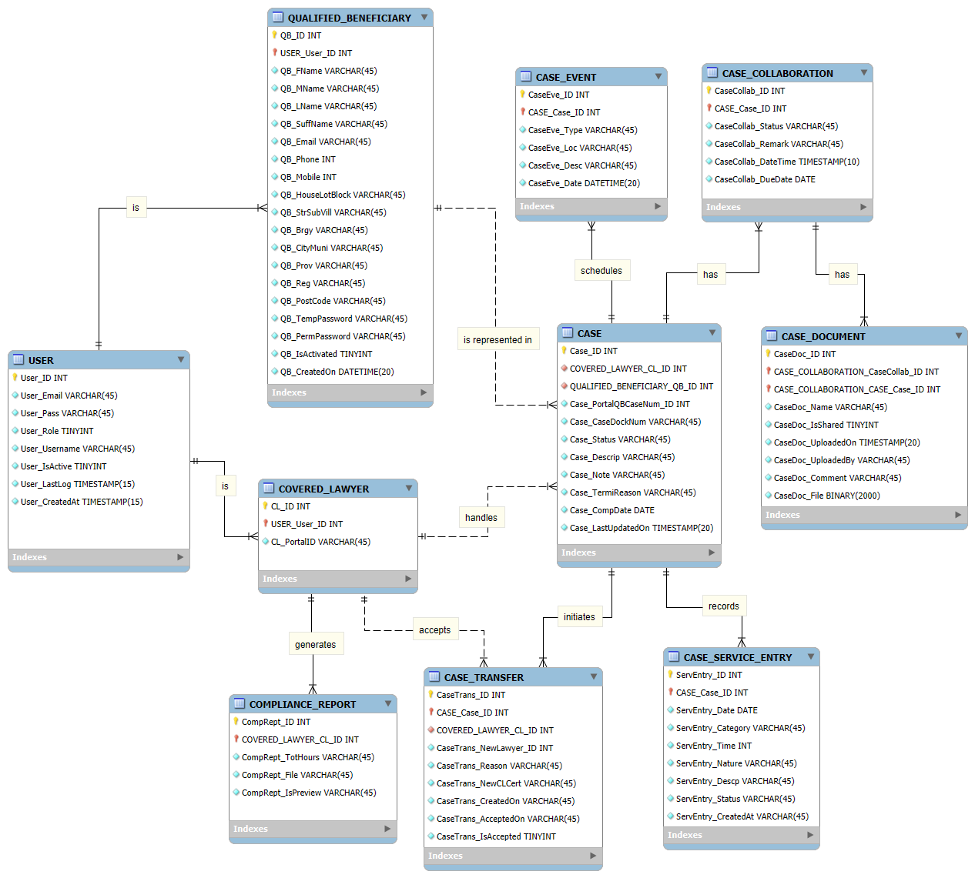

Figure 8: Entity Relationship Diagram

Activity Diagrams
This section presents the Activity Diagrams of ULAS Easy Justice, illustrating the workflow and sequence of actions performed by system users and the system. These diagrams show the flow of activities, decision points, and interactions involved in completing key system functions.

Manage Case
Figure 9 illustrates the Activity Diagram for managing cases, showing the sequence of actions performed by the Covered Lawyer and the system from case access to case updates and completion.
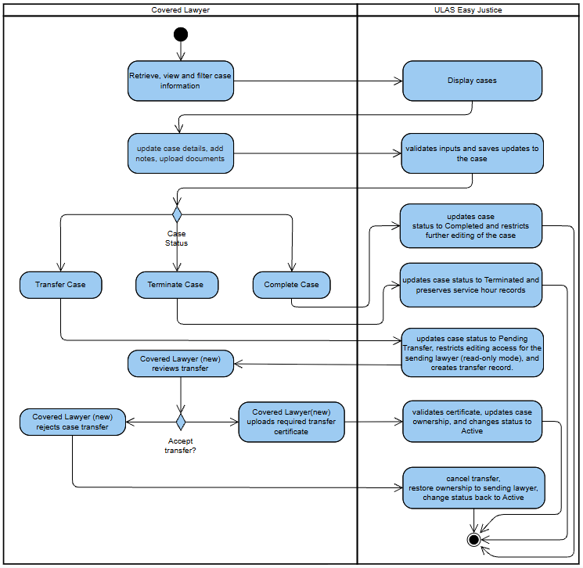
Figure 9: Activity Diagram (Manage Case)
Manage Account
Figure 10 illustrates the Activity Diagram for account management, including login, credential setup, and account access.
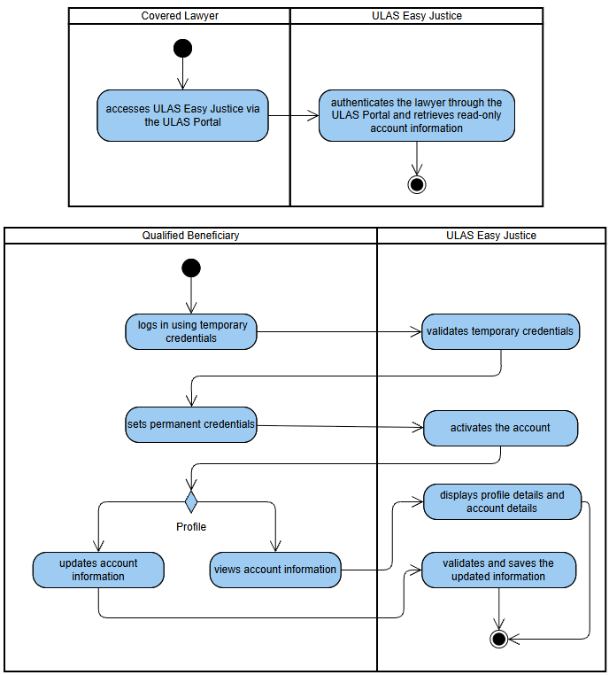
Figure 10: Activity Diagram (Manage Account)

Manage Lawyer- Qualified Beneficiary Collaboration
Figure 11 illustrates the Activity Diagram for Covered Lawyer and Qualified Beneficiary collaboration, including document sharing, and request handling.
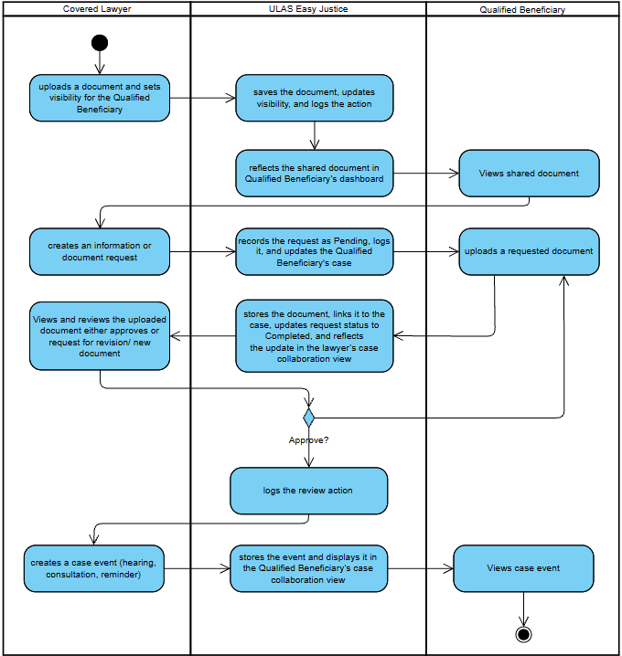
Figure 11: Activity Diagram (Manage Lawyer-Qualified Beneficiary Collaboration)

Manage Service Rendered
Figure 12 illustrates the Activity Diagram for managing service entries, including creation, updating, and compliance tracking.
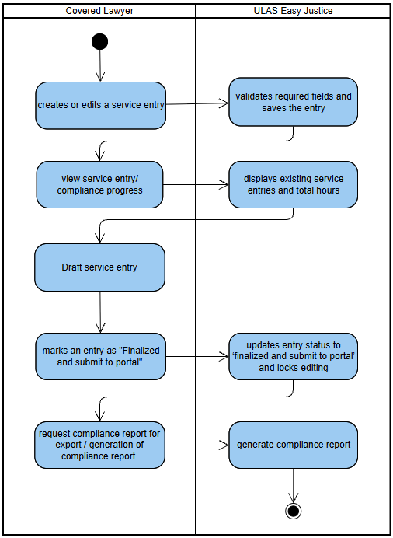
Figure 12: Activity Diagram (Manage Service Rendered)

Deployment Diagram
Figure 13 presents the Deployment Diagram of ULAS Easy Justice, illustrating the physical architecture of the system, including hardware components, system nodes, and their connections. It shows how the application, database, and user devices are deployed and interact to support system accessibility and operation.
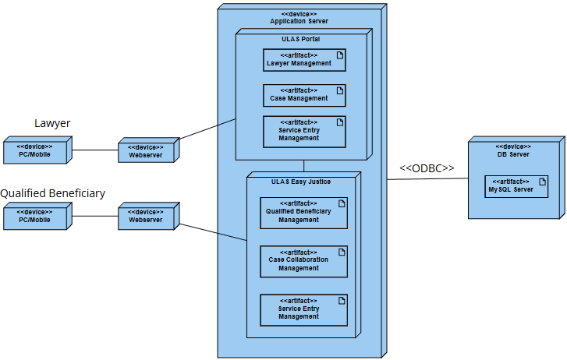
Figure 13: Deployment Diagram

Results and Discussion
This section presents the results of the system design and prototype development of ULAS Easy Justice. It discusses the implemented prototype, identifies the intended user classes and their characteristics, and evaluates how the system meets the defined objectives. It also outlines the current accomplishments and provides recommendations for further improvement and future development.

Prototype
The ULAS Easy Justice system was developed to demonstrate the functional requirements identified during system analysis and design. The following figures present the system interfaces and key features, including case management, account management, collaboration between Covered Lawyers and Qualified Beneficiaries, and service entry tracking. These illustrate how users interact with the system and how the proposed solution supports legal aid case handling and compliance monitoring.
Covered Lawyer Interface
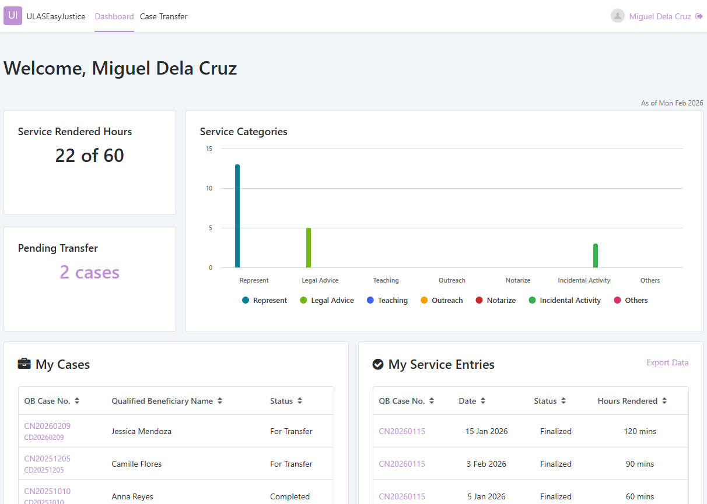
The covered lawyer dashboard serves as the central workspace for Covered Lawyers upon accessing the system. It provides a summary of key information, including total service hours rendered, pending case transfers, and service category distribution displayed through graphical visualization. The interface also presents lists of assigned cases and recent service entries, enabling quick navigation to case details and service management functions. The menu allows access to the dashboard and case transfer modules.
This case transfer interface displays cases pending transfer involving the Covered Lawyer. The table presents relevant information such as QB Case Number, current lawyer, reason for transfer, completion date, and available actions. It supports review and management of transfer requests to ensure proper reassignment of cases within the system.
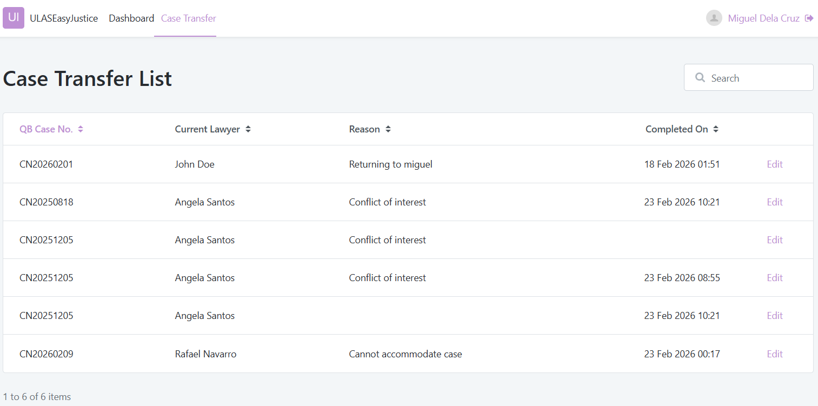
The transfer details interface allows the receiving lawyer to review transfer information and confirm acceptance of the case. Most fields are presented in read-only mode to preserve original case data, while designated fields enable submission of required documentation and transfer confirmation.
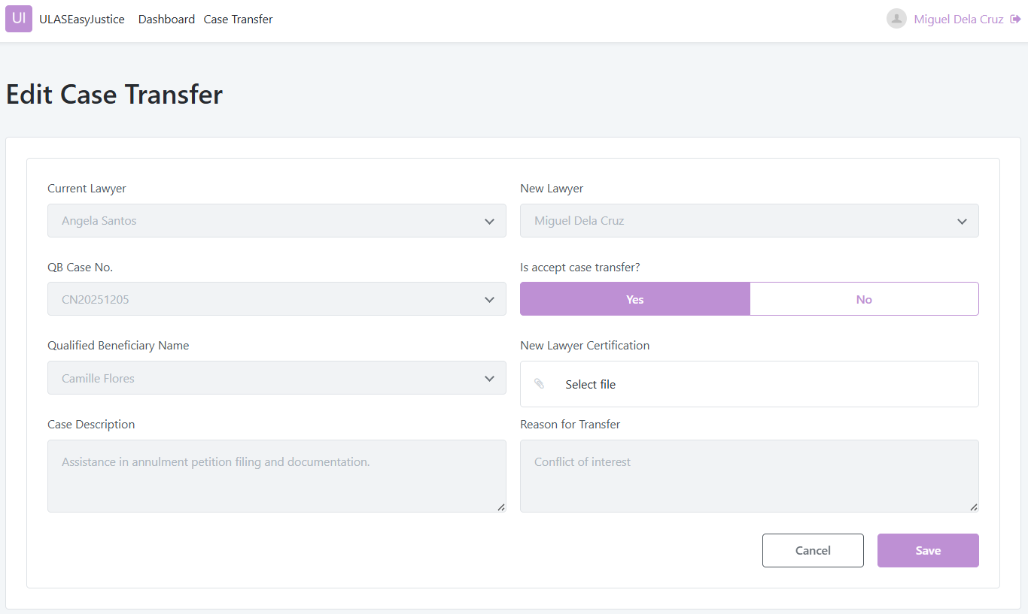
This case overview interface provides a comprehensive view of an individual case. It is organized using tabbed navigation to separate case overview, documents, service entries, and events. The design enables efficient management of case-related information within a single workspace.
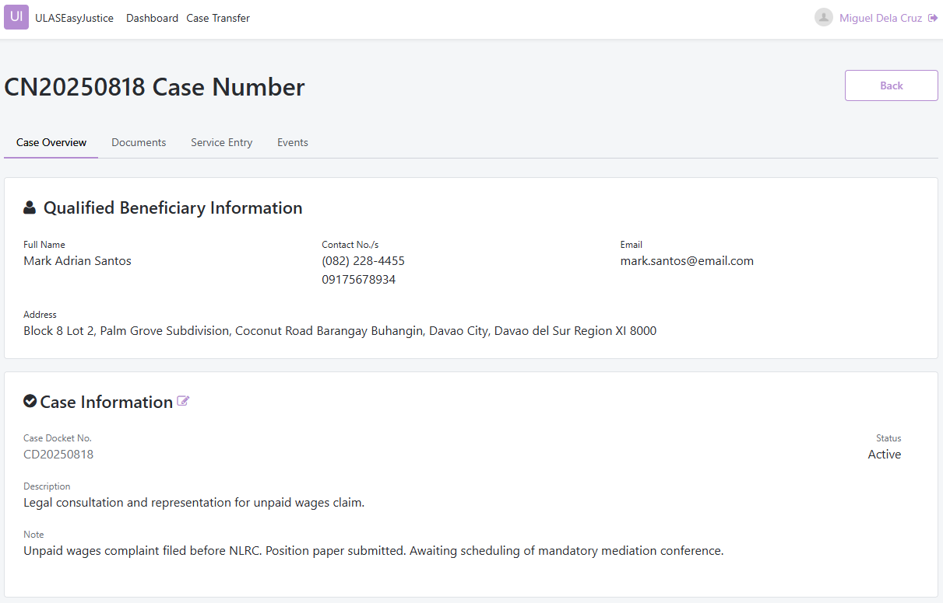
The case detail form allows updating of case status, description, and notes. Conditional fields appear depending on the selected status, such as completion date or termination reason, ensuring that required information is captured accurately.
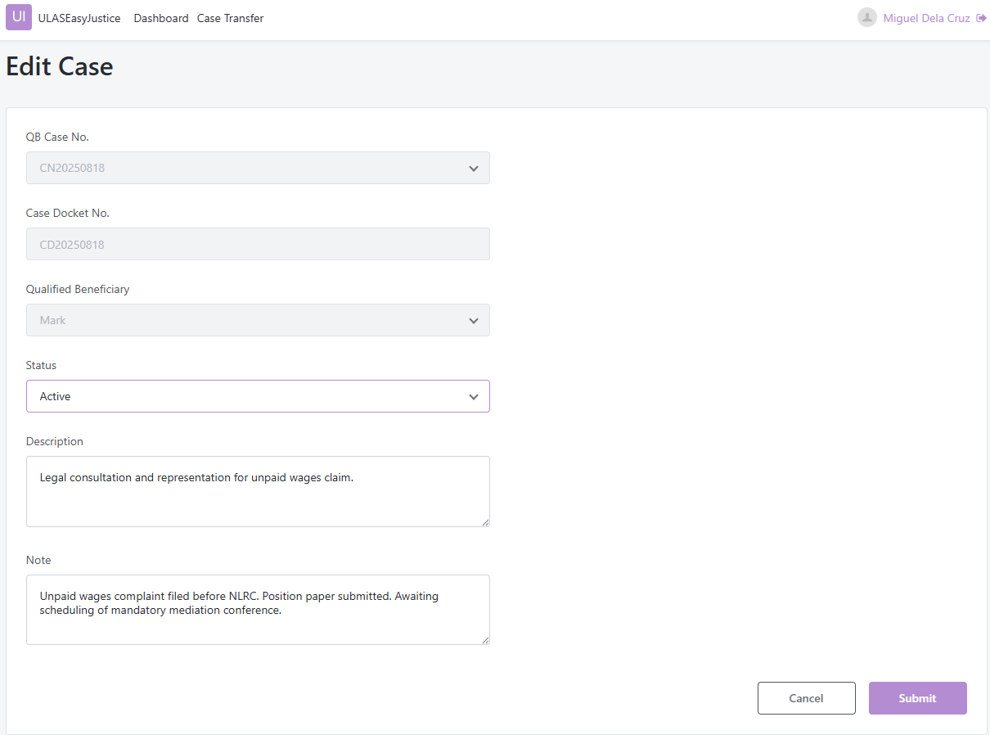
This document management tab interface enables uploading, requesting, and reviewing case-related documents. Quick action controls support document submission and communication with the Qualified Beneficiary, while the document list provides searchable access to all files associated with the case.
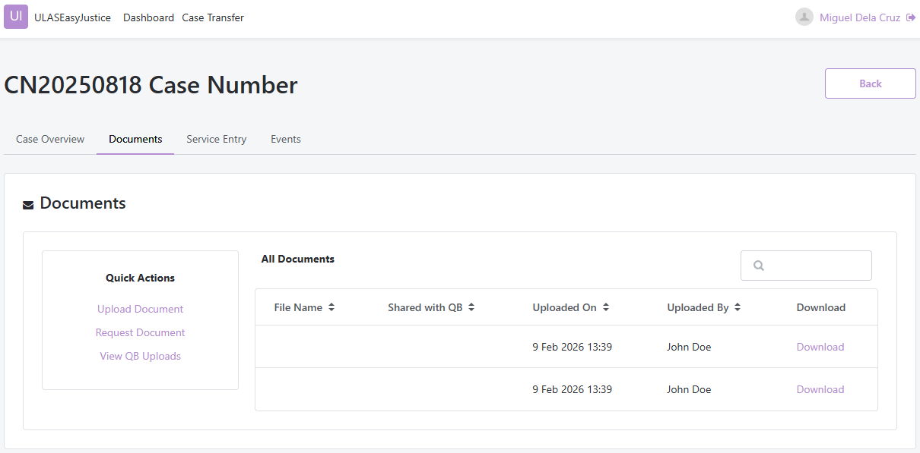
This service entry management tab interface allows recording and monitoring of legal services rendered for a case. Lawyers can create entries by specifying service category, nature, date, duration, and description. Existing entries are displayed in a structured list to support compliance tracking.
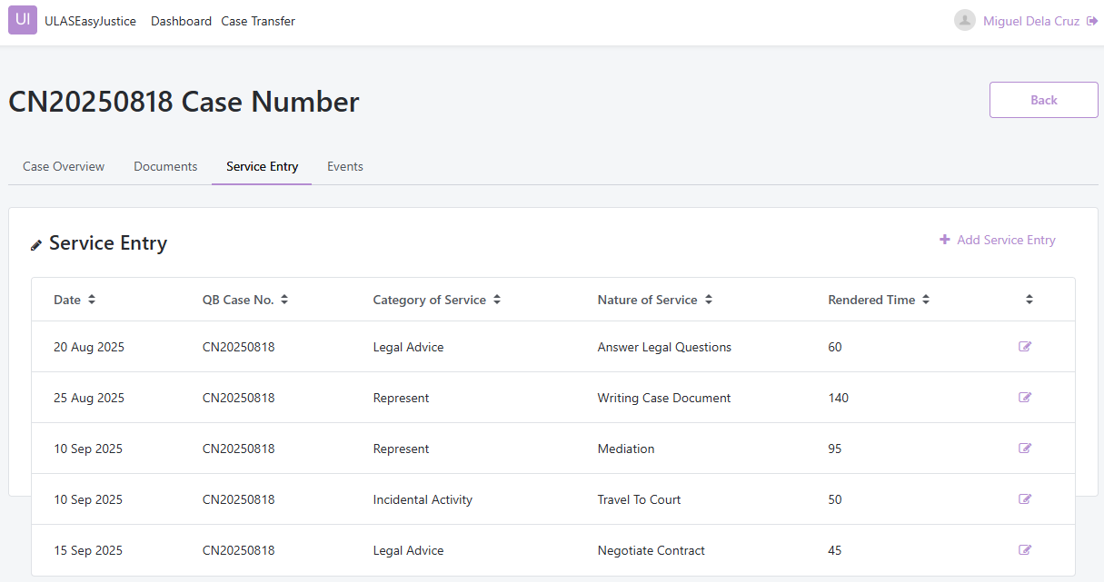
This interface supports scheduling and tracking of case-related events such as hearings, consultations, and reminders. Event details including type, location, remarks, and schedule are displayed to facilitate coordination with the Qualified Beneficiary.
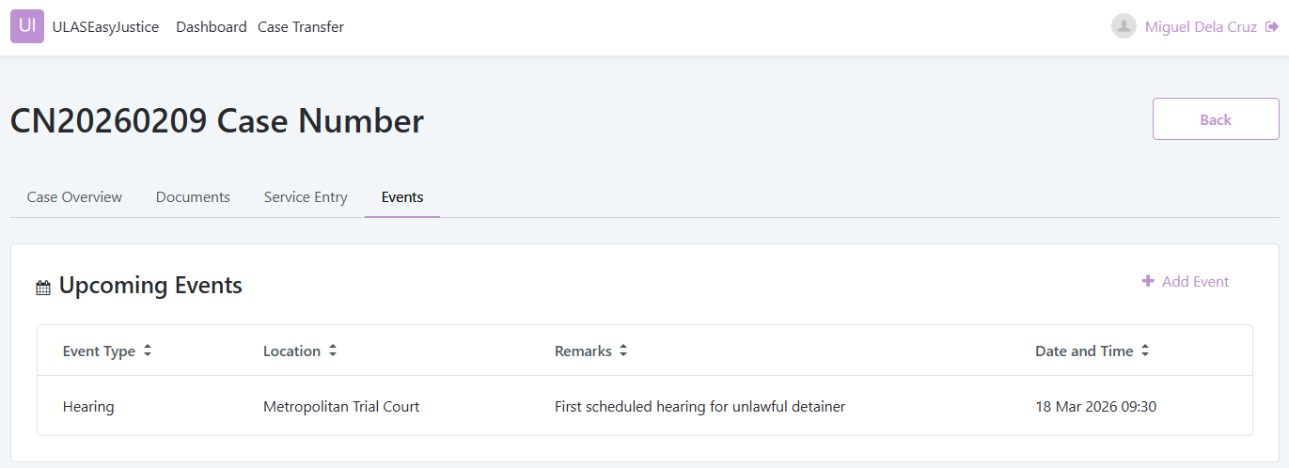
Qualified Beneficiary Interface
First-time Qualified Beneficiaries activate their accounts using temporary credentials. This interface collects personal details and new login credentials to establish secure access to the system.
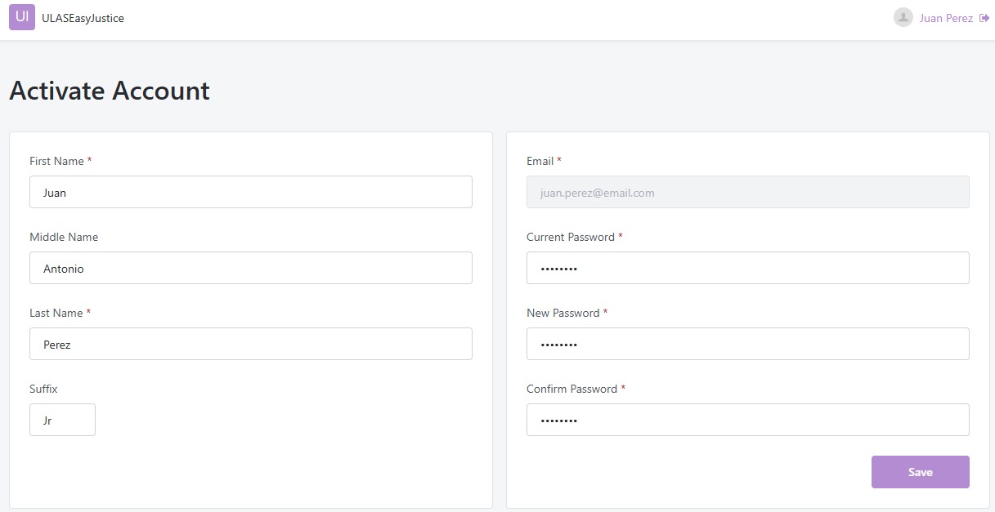
Qualified Beneficiary profile displays the qualified beneficiary’s personal and contact information in a structured, read-only format. The page presents basic details such as name, phone numbers, email address, and full address. A clickable option is provided to edit the profile, which redirects the user to an editable form where the information can be updated.
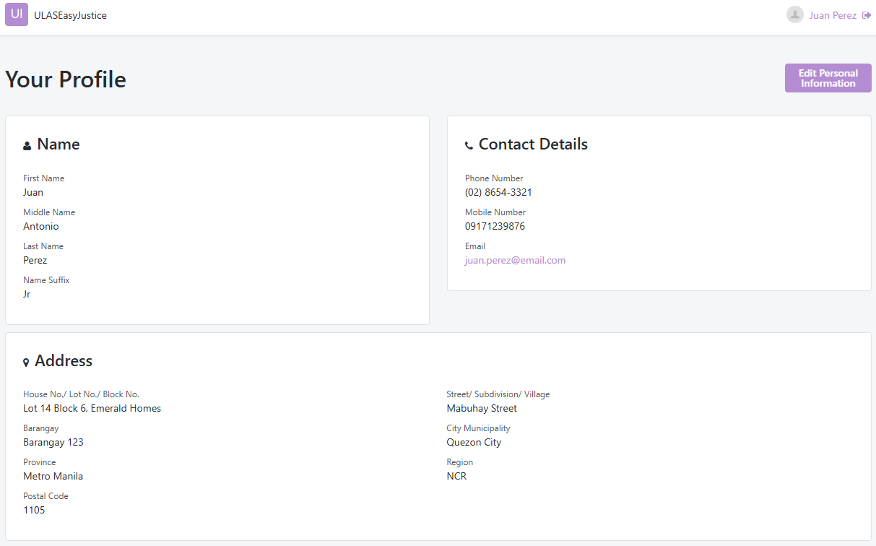
This Qualified Beneficiary interface displays all cases associated with the user. It includes essential details such as case number, assigned lawyer, status, and last update, enabling beneficiaries to monitor their legal matters efficiently.
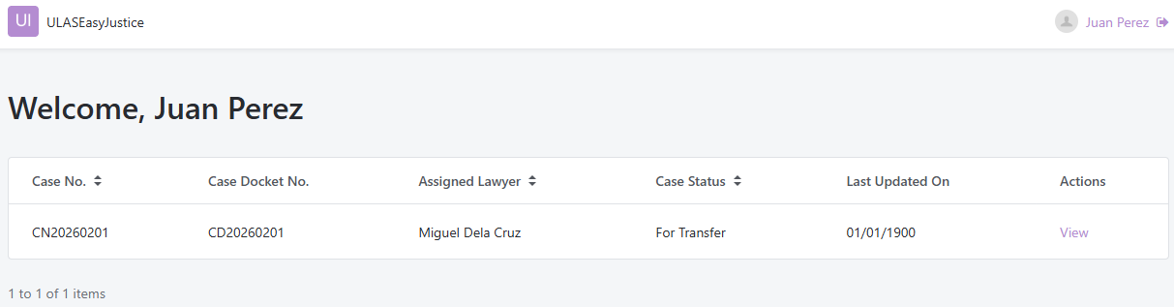

This qualified beneficiary case detail interface provides detailed information about a specific case from the beneficiary’s perspective. Tabbed sections organize case overview, requests and tasks, and upcoming events to support participation in the legal process.
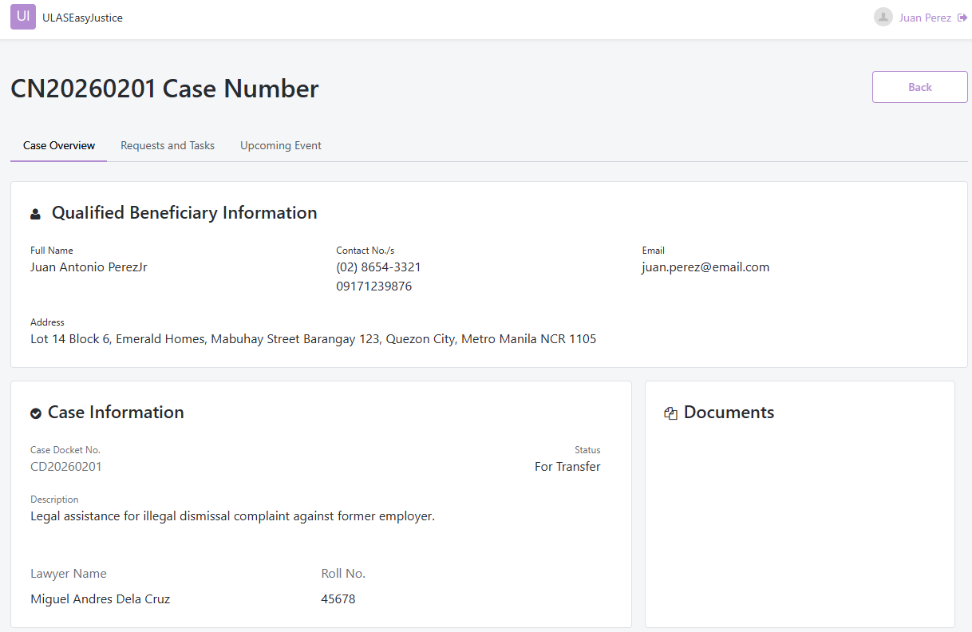
This request and tasks interface allows beneficiaries to respond to lawyer requests by uploading required documents and monitoring request status. It supports collaborative exchange of information necessary for case handling.
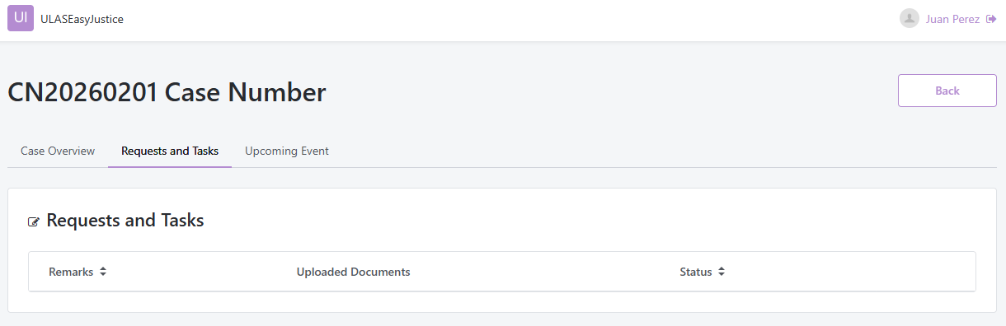

Upcoming events interface displays scheduled hearings, consultations, or reminders associated with the case. This helps beneficiaries stay informed about important legal activities.
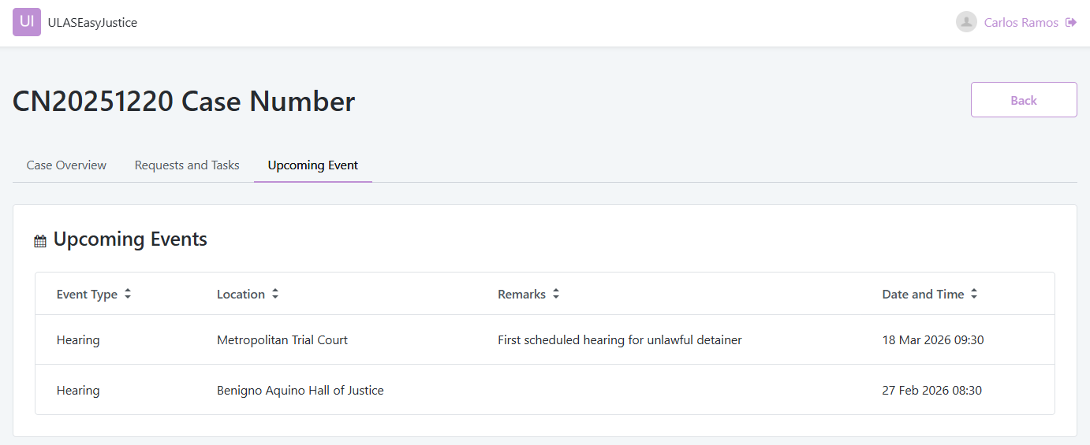

User Classes and Characteristics
The ULAS Easy Justice system supports two primary user classes, each with specific roles, responsibilities, and system access levels. These users interact with the system to manage legal aid cases, maintain account information, collaborate on case requirements, and monitor service compliance.
Table 6: User Classes and Characteristics
Roles | Description
Covered Lawyer | A Covered Lawyer manages assigned legal aid cases, records service entries, uploads documents, collaborates with Qualified Beneficiaries, and tracks compliance with pro bono service requirements.
Qualified Beneficiary | A Qualified Beneficiary accesses their assigned case information, views shared documents, responds to lawyer requests, uploads required documents, and monitors case progress and updates.

Recommendations
The study successfully achieved its primary objective of designing and developing a functional prototype of ULAS Easy Justice. The system supports key features including case management, account management, Covered Lawyer and Qualified Beneficiary collaboration, and service entry tracking, as demonstrated through the prototype and supporting system models. The system structure, data flow, and database design were clearly defined using standard modeling tools such as Data Flow Diagrams, Entity-Relationship Diagram, Activity Diagram, and Deployment Diagram, ensuring alignment between functional requirements and system design.

Future improvements may include full integration with the ULAS Portal, enhancement of notification and document management features, implementation of stronger security and access controls, and comprehensive user testing to evaluate usability and performance. These enhancements would further improve system reliability, efficiency, and readiness for practical deployment in supporting legal aid service management.

References

[1] | Constitution of the Republic of the Philippines, vol. Article III, 1987.
[2] | "Access to Justice Project," United Nations, 2018. [Online]. Available: https://sdgs.un.org/partnerships/access-justice-project.
[3] | H. L. Torregoza, "PAO lawyers succumbing to depression, anxiety—Acosta," Manila Bulettin, 27 October 2025. [Online]. Available: https://mb.com.ph/2025/12/14/bill-that-can-save-pinoys-from-losing-their-homes-due-to-loan-delinquency-gets-final-house-nod.
[4] | Supreme Court of the Philippines, "The Rules on Unified Legal Aid Service," 20 August 2024. [Online]. Available: https://sc.judiciary.gov.ph/wp-content/uploads/2025/05/AM-22-11-01-SC.pdf.
[5] | Supreme Court of the Philippines, "Manual on the Rules on Unified Legal Aid Service," 8 April 2025. [Online]. Available: https://sc.judiciary.gov.ph/wp-content/uploads/2025/10/ULAS-Manual-Resolution-as-of-October-20-2025.pdf.
[6] | Integrated Bar of the Philippines, "IBP Chapters Directory," [Online]. Available: https://www.ibp.ph/chapters. [Accessed 4 December 2025].
[7] | R. A. H. B.S Aswani, "Legal Liason," International Journal of Advanced Research in Science, Communication and Technology (IJARSCT), vol. 4, no. 1, pp. 421-428, 2024.
[8] | Task Force on Justice, "Justice For All," 2019.
[9] | United Nations Development Programme, Access to Justice Assessments in the Asia Pacific: A Review of Experiences and Tools from the Region, Bangkok, Thailand: Asia-Pacific Regional Centre, 2012.
[10] | A. S. Okoro, "Access to Justice: The Role of Legal Aid in Society," Interdisciplinary Studies in Society, Law, and Politics, vol. 1, no. 2, pp. 34-41, 2022.
[11] | M. G. S. Lopez, "The Poor on Trials in the Philippine Justice System," 1999.
[12] | R. P. Valenzuela, "Glimmers of hope: A report on the Philippine Criminal Justice System," International Review of the Red Cross, vol. 98, no. 903, pp. 845-849, 2016.
[13] | J. M. Lodangco, "Bias in the Law: A Definitive Look at Racial Prejudice in the Philippine Criminal Justice System: A Systematic Literature Review," Journal of Advances in Humanities Research, vol. 2, no. 3, pp. 9-33, 2023.
[14] | I. P. Martin, "Expanding the Role of Philippine Languages in the Legal System: The Dim Prospects," Asian Perspectives in the Arts and Humanities, vol. 2, no. 1, pp. 1-14, 2012.
[15] | V. R. I. A. N. E. A. Juralyn M. Abayon, "Stories of Injustice: Lived Experiences of Victimization in the Philippines," EPRA International Journal of Multidisplinary Research, vol. 11, no. 4, pp. 776-785, 2025.
[16] | Clio, "Clio," [Online]. Available: https://www.clio.com/features/.
[17] | My Case, [Online]. Available: https://www.mycase.com/features/client-portal/. [Accessed 28 December 2025].
[18] | "PracticePanther," [Online]. Available: https://www.practicepanther.com/.
[19] | S. Munnangi, "Empowering Access to Justice through," International Journal for Multidisciplinary Research, vol. 6, no. 6, 2024.
[20] | H. G. b. S. R. S. Nikhil M, "E-Portal for Case Management using Artificial Intelligence," International Journal of Scientific Research in Engineering and Management, vol. 9, no. 5, 2025.
[21] | Clio, "Legal Trends Report," Clio, 2025.
[22] | A. P. Stebin Sam, "Community Legal Centres in the Digital Era: The Use of Digital Technologies in Queensland Community Legal Centres," Law, Technology and Humans, pp. 64-67, 2019.
[23] | "Legal Technologies in Action: The Future of the Legal Market in Light of Disruptive Innovations," Sustainability, vol. 11, no. 4, 2019.
[24] | LegalServer, "LegalServer," [Online]. Available: https://www.legalserver.org/features/. [Accessed 28 December 2025].
[25] | Community Legal Centres, "Community Legal Centres," [Online]. Available: https://clcs.org.au/about-us/. [Accessed 28 December 28].
[26] | V. P. B. S. Aniceto Orbeta, "Impacts of Judicial Reform in Utilization of Electronic Court Systems on Court Congestion in the Philippines," 2021. [Online]. Available: https://poverty-action.org/study/impacts-judicial-reform-utilization-electronic-court-systems-court-congestion-philippines.
[27] | B. G. S. Grepon, "Designing and implementing e-justice systems: an information systems approach to regional trial court case docket management in northern Mindanao, Philippines," International Journal of Multidisciplinary Academic Research, vol. 8, no. 1, 2020.
[28] | A. C. T. M. C. J. G. B. R. H. L. R. J. R. &. R. Z. James E. Cabral, "Using Technology to Enhance Access to Justice," Harvard Journal of Law & Technology, vol. 26, no. 1, pp. 243-324, 2012.
[29] | A. S. Richard Moorhead, "An Anatomy of Access: Evaluating Entry, Initial Advice, and Signposting Using Model Clients," Legal Services Research Centre, 2002.
[30] | J. Steinberg, "In Pursuit of Justice? Case Outcomes and the Delivery of," Georgetown Journal on Poverty Law & Policy, vol. 18, no. 3, 2011.
[31] | J. Adawi, "Changing Every Wrong Door into the Right One:," Georgetown Journal on Poverty Law and Policy, vol. 29, no. 3, 2022.
[32] | J. S. Mann, "Impact Analysis of the Legal Aid Services provided by Empaneled Legal Practitioners on the Legal Aid System in City of Delhi," 2017.
[33] | Thomson Reuters, "Client collaboration: The evolution in law firms," [Online]. Available: https://legal.thomsonreuters.com/en/insights/white-papers/client-collaboration-white-paper-the-evolution-in-law-firms. [Accessed 28 December 2025].
[34] | Clio, "Legal Trends Report," Clio, 2023.
[35] | M. D. Hagan, "A Human-Centered Design Approach to Access to Justice:," Indiana Journal of Law and Social Equality, vol. 6, no. 2, 2018.
[36] | R. L. Sandefur, "Access to What?," Dædalus, the Journal of the American Academy of Arts & Sciences, no. 1, pp. 49-55, 2019.
[37] | S. Golub, Beyond Rule of Law Orthodoxy: The Legal Empowerment Alternative, Washington, USA: Carnegie Endowment for International Peace, 2003.
[38] | D. Rhode, "Pro Bono in Principle and in Practice," 2003.
[39] | American Bar Association, "Supporting Justice V," American Bar Association, Chicago, USA, 2024.
[40] | M. P. Andrew Friedman, "Continuing professional development: Developing a vision," Journal of Education and Work, vol. 17, no. 3, pp. 361-376, 2004.
[41] | Law Society of Ontario, "Enhancing Competence & CPD," [Online]. Available: https://lso.ca/lawyers/enhancing-competence. [Accessed 28 December 2025].
[42] | Law Society of Ontario, "Annual Report of the Complaints," Law Society of Ontario, 2024.
[43] | D. L. R. Scott L. Cummings, "Managing Pro Bono: Doing Well by Doing Better," Fordham Law Review, vol. 78, no. 5, 2010.
[44] | Thomson Reuters, "Stop grinding the gears," [Online]. Available: https://legal.thomsonreuters.com/en/forms/technnology-adoption-white-paper?gatedContent=%252Fcontent%252Fewp-marketing-websites%252Flegal%252Fgl%252Fen%252Finsights%252Fwhite-papers%252Ftechnnology-adoption-white-paper&utm_source=chatgpt.com. [Accessed 28 December 2025].
[45] | D. P. M. Pamela Herd, Administrative Burden, Russell Sage Foundation, 2018.
[46] | Australia Pro Bono Centre, [Online]. Available: https://www.probonocentre.org.au/. [Accessed 28 December 2025].
[47] | Legal Services Corporation, [Online]. Available: https://www.lsc.gov/50th-annual-report. [Accessed 28 December 2025].
[48] | Case Status, [Online]. Available: https://www.casestatus.com/. [Accessed 28 December 2025].
[49] | Legal Aid New South Wales, [Online]. Available: https://www.legalaid.nsw.gov.au/about-us/annual-reports/annual-report-2024-25. [Accessed 28 December 2025].
[50] | NYCourts.Gov, [Online]. Available: https://ww2.nycourts.gov/attorneys/probono/reportingreqs-intro.shtml. [Accessed 28 December 2025].
[51] | American Bar Association, [Online]. Available: https://www.americanbar.org/groups/legal_aid_indigent_defense/. [Accessed 28 December 2025].
[52] | Public Attorney's Office, [Online]. Available: https://pao.gov.ph/office-policy-references/pao-operations-manual-specific-mandates/. [Accessed 28 December 2025].
[53] | E. L. a. S. V. Charalampos Alexopoulos, "Architecture and Evaluation of an Advanced Legal Information Platform—Enhancing Productivity of Modern Legal Work," Journal of the Knowledge Economy, vol. 15, p. 8654–8681, 2024.
[54] | A. C. A. T. Negado, "Purpose in Practice: Embracing ULAS as a Bold Step Toward Justice," P&A Grant Thornton, 10 June 2025. [Online]. Available: https://www.grantthornton.com.ph/insights/articles-and-updates1/line-of-sight/purpose-in-practice-embracing-ulas-as-a-bold-step-toward-justice/.

Appendices

Appendix A: Schedule

Activities | Wk 1 | Wk 2 | Wk 3 | Wk 4 | Wk 5 | Wk 6 | Wk 7 | Wk 8 | Wk 9 | Wk 10 | Wk 11 | Wk 12 | Wk 13 | Wk 14 | Wk 15
Activities | Nov 13 - 19 | Nov 20 - 26 | Nov 27 - Dec 3 | Dec 4 - 10 | Dec 11 - 17 | Dec 18 - 24 | Dec 25 - 31 | Jan 1 - 7 | Jan 8 - 14 | Jan 15 - 21 | Jan 22 - 28 | Jan 29 - Feb 4 | Feb 5 - 11 | Feb 12 - 18 | Feb 19 -25
Project Planning & Topic Finalization | X | X
Adviser Selection & Coordination | X | X | X
Requirements Gathering & ULAS Study |  | X | X | X | X | X
Chapter 1 Writing & Revisions |  | X | X | X | X | X | X
User Stories & Use Case Development |  | X | X | X | X | X | X
System Analysis & Modeling |  |  | X | X | X | X | X |  | X | X | X | X
RRL Writing |  |  |  |  |  |  | X | X
Initial App Development |  |  |  |  |  |  |  | X | X | X
Midterm Defense Preparation & Revisions |  |  |  |  |  |  |  | X | X
Diagram Refinement & Documentation Updates |  |  |  |  |  |  |  |  | X | X | X | X | X | X
Core Feature Development & Interface Design |  |  |  |  |  |  |  |  |  | X | X | X | X | X | X
Testing & Iterative Improvements |  |  |  |  |  |  |  |  |  | X | X | X | X | X | X
Adviser Reviews & Deliverable Checking | X | X | X | X | X | X | X | X | X | X | X | X | X | X | X
Finalization & Preparation for Defense |  |  |  |  |  |  |  |  |  |  |  |  | X | X | X

Appendix B: Users’ Manual

User manual can be accessed in this link

Appendix C: Team Meetings

November 20, 2025
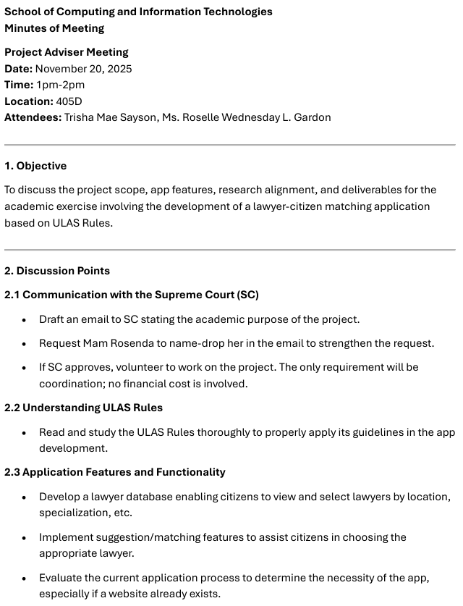
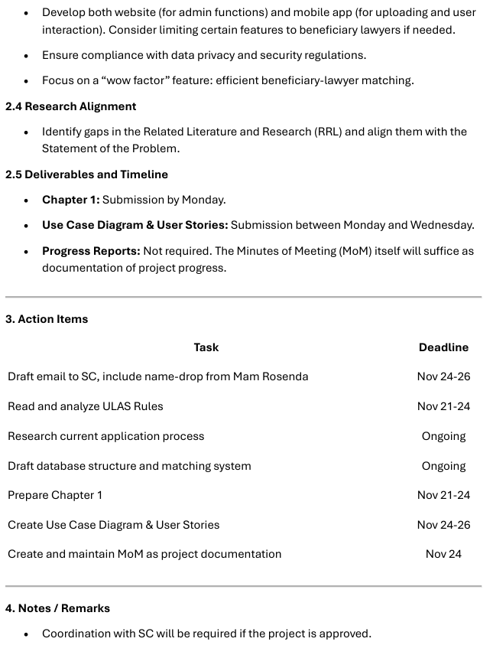
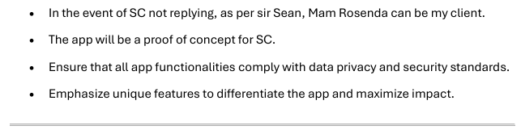

November 27, 2025
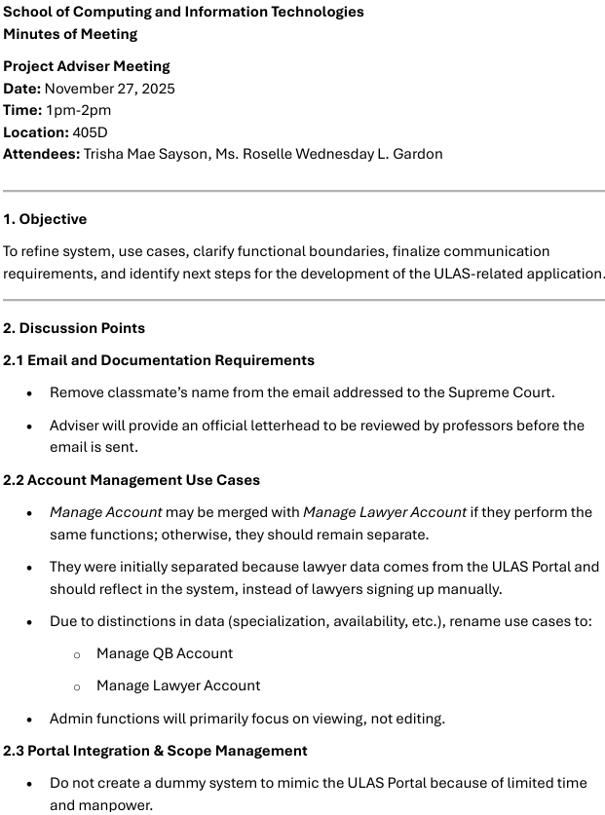
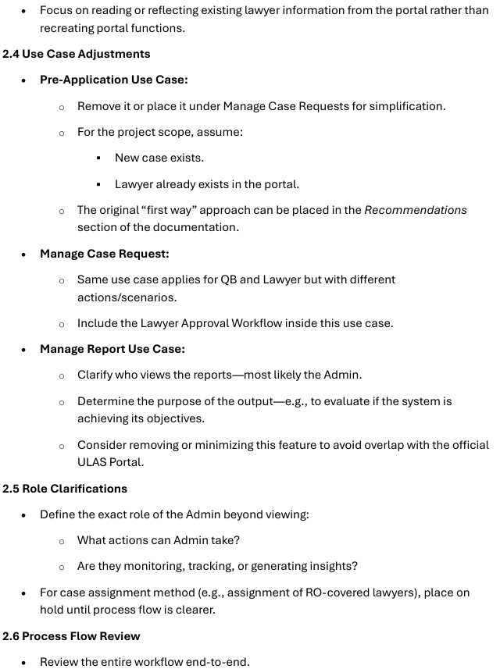
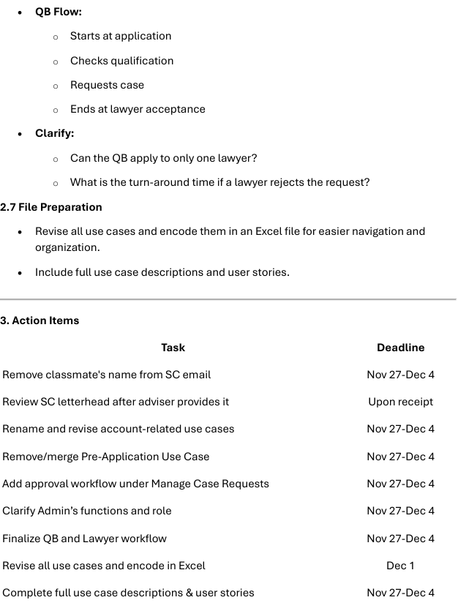
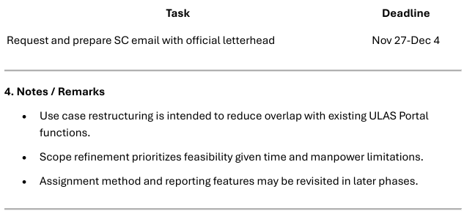
December 11, 2025
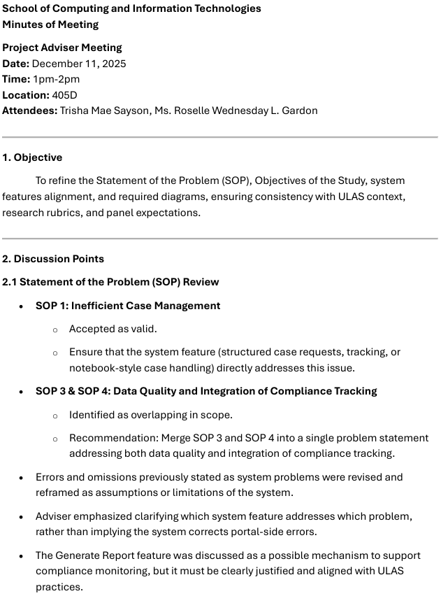
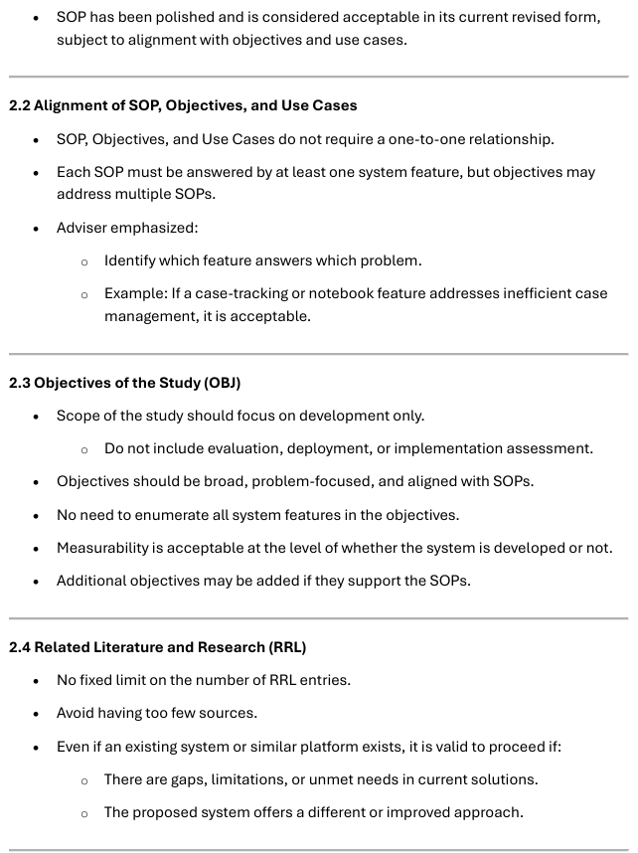
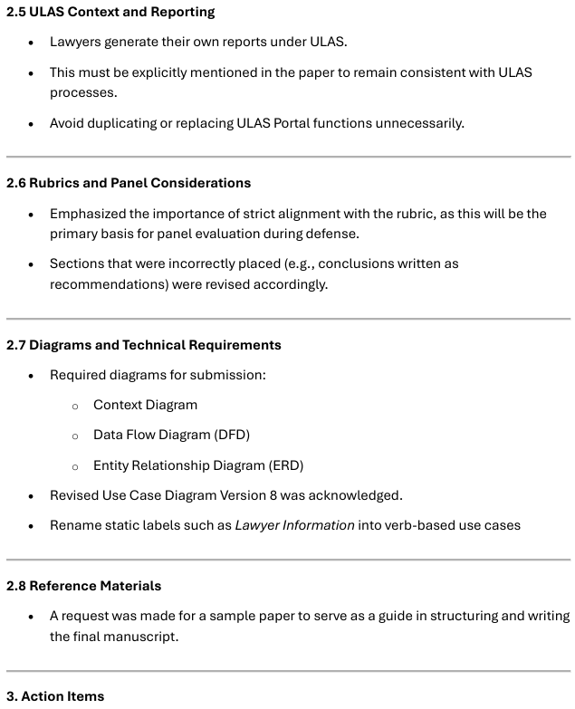
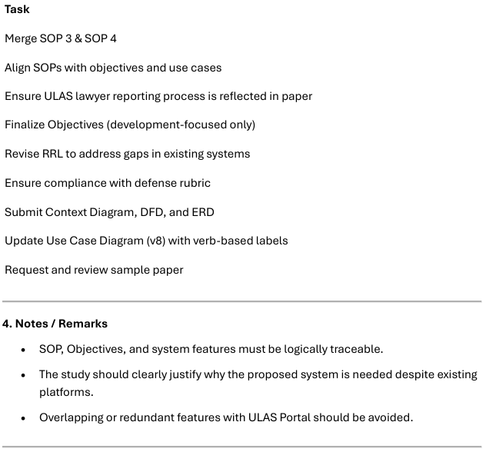
January 8, 2026
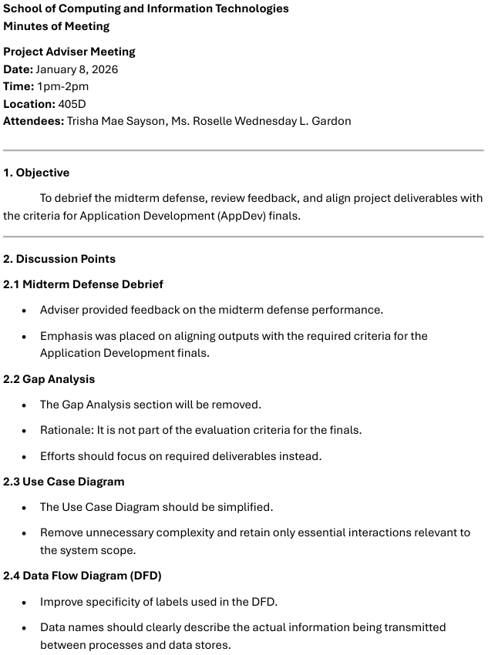
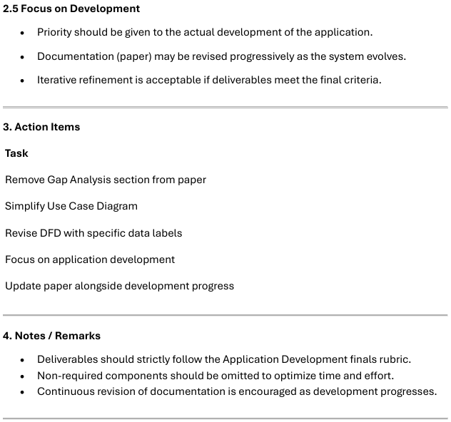
January 26, 2026
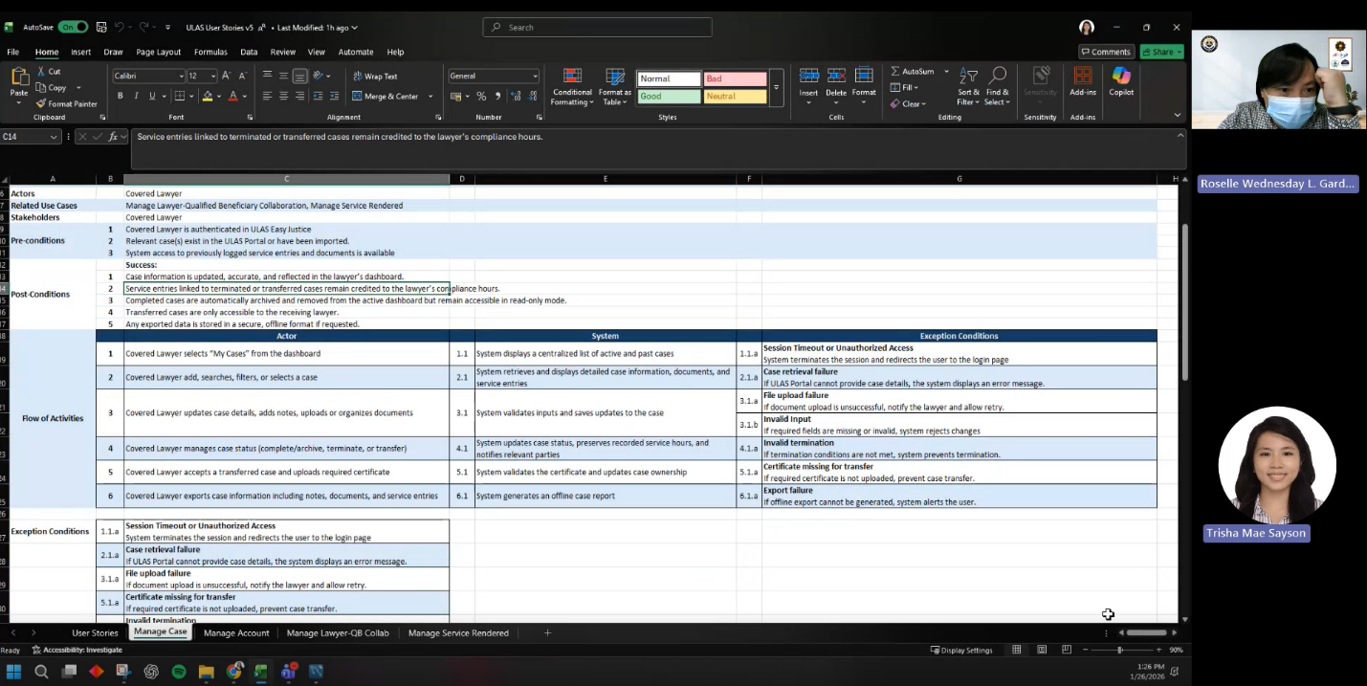

January 29, 2026
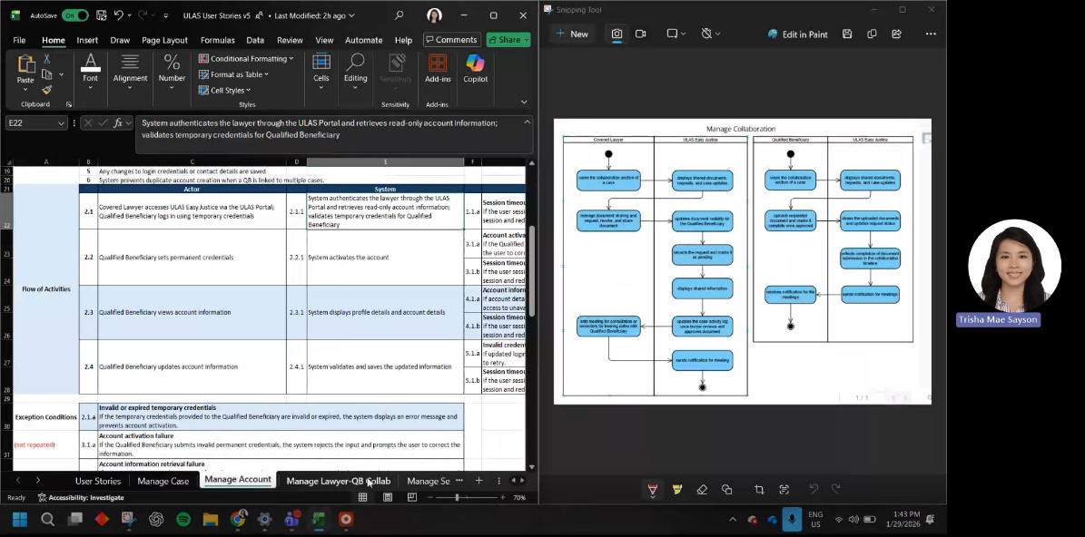
February 5, 2026
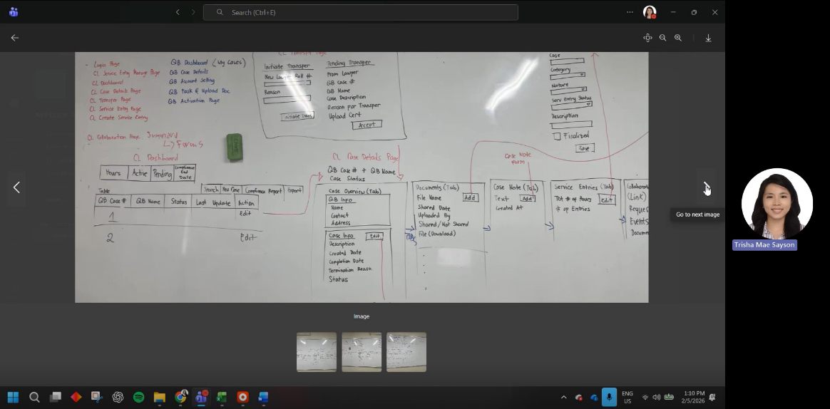
February 9, 2026
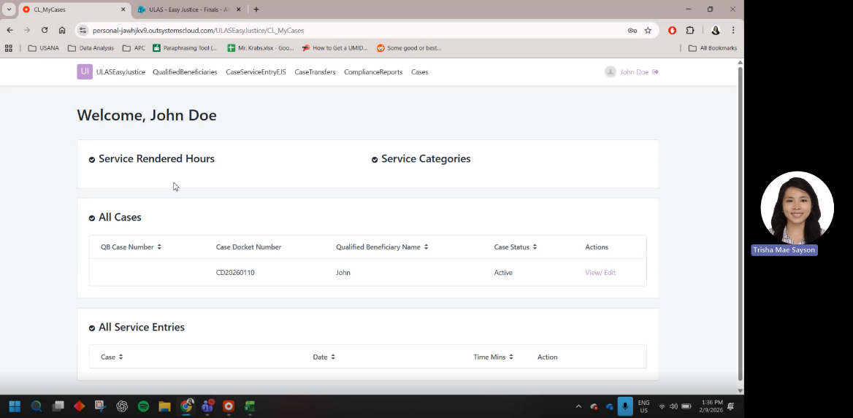

Appendix D: Source Code

Source Code can be accessed in this link

Appendix E: Curriculum Vitae

Name: | TRISHA MAE V. SAYSON | 
Complete Address: | 65 Rafaela 1 Ampid 1,
 | San Mateo, Rizal
Contact Number: | Mobile No.: (0927) 881-0168
Email Address: | tvsayson2@student.apc.edu.ph  tmvsayson@gmail.com
Website: | https://www.linkedin.com/in/trisha-mae-v-sayson-383387167/

Personal Statement | Analytical and results-driven professional with experience in procurement, market research, and data reporting, skilled in transforming data into actionable business insights. Experienced in database development, supplier evaluation, and research analysis using tools such as Excel, SPSS, and Python. Committed to supporting data-driven decision-making and improving operational efficiency through structured analysis and process optimization
Education | Asia Pacific College, Magallanes, Makati City  Associate in computer technology - Full Stack Development Track  November 2025-present  Centro Escolar University, Mendiola, Manila City  Bachelor of Science in Psychology  June 2015-March 2019
Work-Related Courses | - Data Management and Administration  - Programming Concepts and Logic  - Data Structure  - Web Programming  - Application Development
Academic Projects | ULAS Easy Justice  - Systems Development Capstone Project, November-February 2025  - Project Manager  - Designed and developed a platform to support pro bono legal services by enabling compliance tracking, case documentation, and case visibility.  Effects of Emotional Freedom Technique (EFT) on Test Anxiety and Test Result  - Academic Research, June 2018 – March 2019  - Project Leader  - Conducted to evaluate the impact of EFT which demonstrated significant improvement in anxiety levels and test outcomes among treated participants.  - Recognized in 17th EdukCircle International Convention on Psychological Communication, September 2019
Technical Skills | - Proficient in IBM SPSS Statistics for data tabulation and basic statistical analysis  - Knowledge in Python for data handling and analysis  - Proficient in MS Office: Word, PowerPoint, Excel, Outlook  - Working knowledge of VTiger CRM, Monday.com, Trello, M360, and SendGrid  - Experience in database creation and process streamlining
Certifications | - IBM Skills Build Agile Explorer, Asia Pacific College November 2025  - IBM Skills Build Data Fundamentals, November 2025  - IBM Skills Build Web Development Fundamentals, Asia Pacific College September 2025  - Udemy Complete Data Analyst Bootcamp, July 2025
Awards & Recognitions | - Registered Psychometrician, Professional Regulation Commission License No. 0022517, 2019-2022  - Cum Laude, Centro Escolar University, 2019
Seminars & Trainings Attended | - Purchasing and Procurement Training  International Market Brands, January 2023 – August 2024  - Market Research Training  Philippine Survey and Research Center, May 2022 – November 2022  - Innovation Trainings  Philippine Survey and Research Center, December 2021-January 2022

Appendix F: Links

- Source Code
- ULAS Documents
- Diagrams
- Signed Project Adviser Form

